ГБОУ СПО « КАМЧАТСКИЙ МЕДИЦИНСКИЙ КОЛЛЕДЖ»

Учебное пособие
для студентов медицинских колледжей

Беленкова Г.А., преподаватель английского языка,
Глазова Н.С., преподаватель английского языка.

Петропавловск-Камчатский
2013 год.

Содержание
Введение……………………………………..………………….…………….… 4

Раздел I. Student’s Life

Topic 1. Kamchatka -My Native Land.............................................………………...6
Topic 2. Our Medical School. My Future Profession…....................………………12

Раздел II. Development of Medicine

Topic 3. Early Medicine............................................………………………….........18
Topic 4. Medical Myths......................................………………...............................29
Topic 5. Changes in Medical Care.................................………………....................37
Topic 5.1. The Discovery of the X-ray.....……………......................…...................43
Topic 5.3. Public Health in the USA...................................................……………...46
Topic 5.4. Public Health in Russia................................................……………….....47

Раздел III. Human Anatomy

Topic 6. The Human Body. Parts of the Body................………………...................50
Topic 7. Skeleton...............................................................................………………59
Topic 7.2. Great Music......................................................................………………66
Topic 7.3. Health in Space.................................................................………………68
Topic 8. The Major Systems of the Body............................................…..…………71
Topic 9. Cardiovascular System........................................................………………80
Topic 9.1. Evolution of the Heart.......................................................………………89
Topic 9.2. The Human Heart..............................................................………………91

Раздел IV. Diseases

Topic 10. Ulcer..................................................................………………................93
Topic 11. Pneumonia........................................................................………...……102
Topic 11. 1. Pneumothorax...............................................................……………...107

Раздел V. Food as Treatment

Topic 12. Vitamins..............................................................………………............109
Topic 13. What Should a Man Eat?...................................................…………….115

Раздел VI. Texts for Additional Reading

Text 1. Pediatrics................................................................…………..………… 122
Text 2. Nursing of Children During Illness........................……………………….122
Text 3. Heart Disease Risks..................................................……..…………….. 123
Text 4. Accessory Aids of Blood Circulation...................………….………….. 123
Text 5. Heart Failure...........................................................…………… ………..124
Text 6. Heart Block.............................................................………………………125

Text 7. Heart Burn..............................................................………………………125
Text 8. Heat Exhaustion......................................................………………………126
Text 9. Chromosomes.........................................................………………………126
Text 10. Chronic Fatigue Syndrome...................................………………………127
Text 11. Chronic Gastritis...................................................………………………127
Text 12. Chronic Leukaemia...............................................………….…………...128
Text 13. Operations a Hundred Years Ago.........................…………..…………..128
Text 14. The Road to Painless Surgery....…………….........................…………..129
Text 15. Surgery.......................................................…………….........…………..130
Text 16. Operating room Techniques................................…………………….....130

Раздел VII. Applications

1. Tables.................................................................………….……....……….…...132
2. Diet and Diseases............................................................………………………139
3. General Measures...........................................................….……………………145
4. Latin Words Used...........................................................………………………147
5. Medical Terminology......................................................………………………148
6. Views of Kamchatka ……………………………………………………… ...151
7. Anatomy Plates……………………………..………………………………….152

Literature…………………….…………………………...………………… …151

Введение

Настоящее учебное пособие предназначено для студентов медицинских коддеджей, продолжающих изучение английского языка на базе полного среднего образования в соответствии с требованиями Федерального государственного стандарта специальностей среднего медицинского и фармацевтического образования и может использоваться как самостоятельное пособие, так и в качестве дополнения к базовым учебникам.
Цель данного пособия - расширение словарного запаса обучающихся, развитие речевых навыков и умений, активизация познавательных и коммуникативных ресурсов личности.
Сформировать у студентов умения использовать английский язык как средство профессионального общения – это задача, которую помогает решить данное пособие.
Предлагаемое пособие содержит тексты, заимствованные из современной английской и американской литературы по медицине, обработанные и адаптированные для данного контингента обучающихся.
Учебное пособие включает следующие разделы:
-Студенческая жизнь
-Развитие здравоохранения за рубежом и в России
-Анатомия человека
-Болезни
-Диетотерапия
-Тексты для дополнительного чтения
-Приложения: 1. таблицы
2. перечень болезней и диет
3. метрическая система мер
4 латинские термины
5. медицинская терминология
6. виды Камчатки.
7. анатомические таблицы
Каждый текст в разделе содержит комплекс упражнений для усвоения и активизации лексико-грамматического материала и формирования соответствующих навыков, а также развития речевых умений. Поскольку данное пособие предназначено для студентов, продолжающих обучение, в пособии представлен также и углублённый грамматический материал (напр., Adjective clauses, the Subjunctive Mood и др.). Преподавателям предлагается осуществлять контроль грамматических навыков непосредственно в процессе самой речевой деятельности, а также использовать с этой целью специальные контролирующие упражнения.
Первый раздел включает региональный компонент, что отвечает требованиям «Рекомендаций по разработке рабочих программ учебных дисциплин по специальностям среднего професси0онального образования».
Каждый раздел заканчивается контрольным упражнением, позволяющим преподавателю определить степень усвоения лексико-грамматического материала.
Данное пособие рекомендуется использовать как для самостоятельной внеаудиторной работы студентов, так и для работы в аудитории. Проверка усвоения материала осуществляется на занятиях в виде текущего контроля.
Учебное пособие позволяет преподавателю организовать самостоятельную и творческую деятельность студентов, направленную на решение профессионально важных проблем и реализует принципы продуктивного подхода в обучении с целью повышения качества подготовки специалистов в рамках изучения дисциплины «Английский язык».

Раздел I. Student’s Life.

Topic 1. Kamchatka - My Native Land.

1. Fill in the gaps with the missing remarks.

Mr. White: How do you do ?
Tourist:.......
Mr. White: I wonder, where are you from?
T.:........
Mr. White: Is our region beautiful?
T.:........
Mr. White: Do you like our town?
T.:.......

2. Look at the picture. Would you like to visit this region? Why?
See the application № 6.

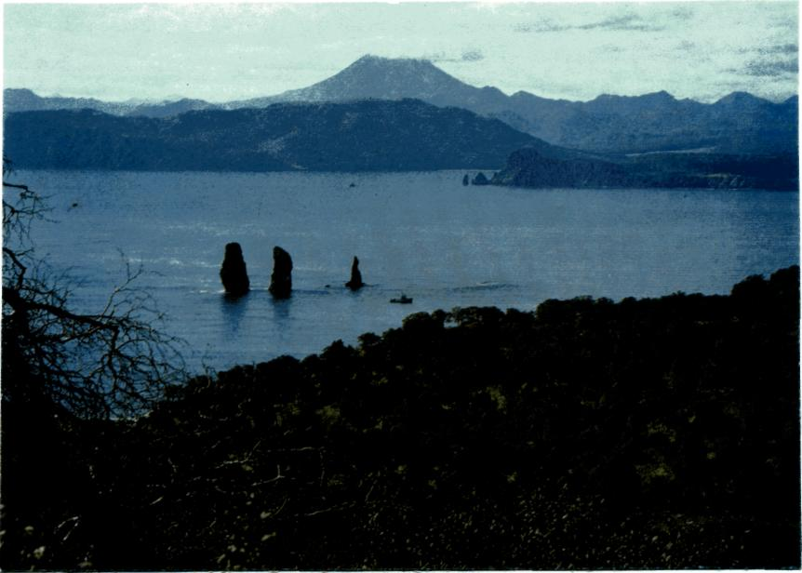

3. Look through the data on tourism in Kamchatka

- Kamchatka had 2 thousand visitors in 1992 and 30 thousand in 2004.
- The population of Petropavlovsk-Kamchatskiy is about 180 thousand.
- Seventy per cent of the visitors to the town are foreigners.
- The tourism industry is worth two thirds of money to budget a year.
- The tourism industry supports 1,5 000 jobs.
- Kamchatka has 10 museums and galleries.

How do you think tourism influences the life of population of the peninsula?

4. Study new words

-native land- родной край
-the peninsula- полуостров
-to stretch for- простираться на
-census- перепись населения
-inhabit- населять
-evens- эвены
-chukchi- чукчи
-koryaks- коряки
-ittelmens- ительмены
-develop- развивать
- fishery- рыболовство
-the main branch of industry- основная отрасль промышленности
-coast- побережье
-to be washed by- омываться
-timber- лес
-woodworking- лесоперерабатывающая
-coal-mining- добыча угля
-cattle-farming- скотоводство
-poultry-farming- птицеводство
-places of interest- интересные места, достопримечательности
-packet-boats- пакетбот
-in honour of- в честь

5. Read the story of the medical school student about his native land
and do the tasks after the text.
I'd like to tell you about my native land, which is called the peninsula of Kamchatka. Our peninsula is situated in the very eastern part of Russia. The territory of Kamchatka is about 470 thousand sq.kms. It stretches for 1.200 kms. from the north to the south. The population of Kamchatskaya region is about 240.000 people. There was no general census of population in our region for a long time, so the figures are not exact. People of different nationalities inhabit our peninsula. Among them there are many native people such as: evens, chukchi, koryaks, ittelmens and others, in other words Kamchatka is a multinational region. Kamchatka is also a very rich region, many industries are developed there. We cannot but mention about fishery because it is considered to be the main brunch of industry. As we know the coasts of Kamchatka are washed by seas and the Pacific Ocean from different sides. The other main industries are: crab-fishing, ship repairing, timber, woodworking, coal-mining and others. As far as agriculture there is vegetable growing, cattle farming, dairy-farming, poultry-farming and reindeer breeding and others on the peninsula. Petropavlovsk is the capital of Kamchatskaya region. It's an administrative, industrial, political and cultural center of Kamchatka. The population of Petropavlovsk is about 180.000 people. There are many places of interest in Petropavlovsk, such as: the monument of Vitus Bering, the Maksutov's battery, the historical museum, the regional library and many others. The history of the town is long and interesting. It was in 1740 when two packet-boats St.Peter and St.Paul came into the Avacha Bay under the command of V. Bering and a small village was built on the shore. And in honour of these two packet-boats our town has got the name of Petropavlovsk. And finishing up my story I'd like to add that I like my town and our peninsula because I was born there, and it's my native land. Petropavlovsk is also considered to be the advanced post of Russia and I am proud of it.

6. Find in the text English equivalents for the following.

- называется полуостровом
- самая восточная часть
- общая перепись населения
- цифры не точны
- люди различных национальностей
- коренные жители
- другими словами
- многонациональный регион
- нельзя не упомянуть
- считается главной отраслью промышленности
- небольшая деревня была построена на берегу
- форпост России

7. Use the words from Ex.3 to translate the underlined phrases in
these sentences

- Территория этого края простирается на многие сотни километров.
- Ительмены и коряки считают Камчатку родным краем.
- Много национальностей населяют этот край, поэтому он считается
многонациональным.
- Основная отрасль экономики региона - рыбная промышленность.
-Туристы приезжают на полуостров, чтобы посмотреть его
достопримечательности.
- Столица полуострова получила своё название в честь двух
пакетботов.

8. Find in the text the following

1. The hints that help you to understand what climate in Kamchatka is.
2. The things that make Kamchatka attractive for tourists.
3. The reason for considering Kamchatka a very rich and prospering region.
4. Kamchatka has long and rich history.

9. a) Express your regret following the example. Use “If only…+
Ved2”

Example: If only there were more interesting roots.

1. There are few tourists from Russia to Kamchatka.
2. The roads of Petropavlovsk-Kamchatskiy are not good enough.
3. The country lacks stability.
4. The main street lamps are not lit at night.
5. Not all Russians can afford to travel to Kamchatka.

b) Your friend might regret the following things. Express his
regret according to the example. Use “If only…+had+Ved3”

Example: If only the authorities had supported the development of fishing
industry.

1. Foreign tourists seldom come to Viluchinsk.
2. The authorities didn’t renovate the monuments.
3. The government didn’t invest enough money in the development of tourism in
Kamchatka.
4. Good shopping and parking facilities are not provided on the peninsula.
5. The tourist agency “Putnic” produced a low quality booklet about the town.

10. Complete the sentences using anything but ( что угодно, только
не… )

1. “Your so-called interesting root is…!”
2. “What? Another excursion?...”
3. “This church is a masterpiece, you say? It is…”
4. “Can’t say I feel attracted by the looks of the streets…”
5. Please do not take us there. We are…”

11. Choose any sentence from this exercise, expand it and exchange
your ideas with your class mates.

12. In pairs exchange your ideas about the following.
Use “…might\may…”, “probably”, “It’s quite possible
that” in your answers

- What would you recognize as a “brand” of Kamchatka?
- What is the influence of the washing seas and the ocean?
- What do you think about the growth of population of Kamchatka?
- What other places of interest in Petropavlovsk do you know?
- What makes Kamchatka unique?
- What are the roots of this uniqueness?

13. Prove that

- Kamchatka is a multinational region.
- Kamchatka is a very rich region.
- Kamchatka is attractive for tourists.
- the history of the town is long and interesting.
- Petropavlovsk is the advanced post of Russia.
- Kamchatka is worth seeing.

14. Make a list of features which can make your region attractive to
tourists.

- architectural monuments
- historic sites
- landscape
- cultural life
- sports facilities
- museums and exhibitions
- others

Using What You’ve Learned

1. Continue the list of things that, in your opinion, are needed to make your
region attractive as tourist destination and tell it to your classmates. Use the
views of Kamchatka from the application №6.

2. Imagine that you are a guide. Your task is to tell your tourists the most
interesting and amazing information about your native land.

2. Choose an event in history of your region or from life of a famous person of
Kamchatka that you would like to know more about. Do some research on
this event or person. You may want to ask a fellow classmate, a friend, a co-
worker, or a teacher for help or additional information. At another class
meeting, give a brief report telling what you learned and how you found the
information.

Topic 2. Our Medical School.
My Future Profession.

1. In groups think of the most prestigious areas of professional
activity and recall the jobs related to them.
Why have you chosen profession of a medical worker?

2. What skills, qualities and abilities will you need working as a
medicine-worker? Look through the list of job requirements and
classify them according to these categories.

Skills | Qualities | Abilities

Job requirements:

- love to people
- noble heart
- a sharp mind
- ambition
- numeracy and literacy
- artistic ability
- dedication
- administrative skills
- individuality
- initiative
- ability to work to tight deadlines
- physical strength
- teamwork skills
- leadership
- flexibility

3. Give reason of your viewpoint

4. What would you like to get from your future job?
Write a wish list of your expectations in terms of:

Example: I’d like to be able to help my relatives and it gives me much
satisfaction.

I’d rather have flexible working hours in a hospital than stay in the
office from 9 to 5.

- holidays
- satisfaction
- salary
- additional benefits
- leisure time
- family practice
- to practice medicine
- to examine a patient
- massage
- perform duodenal intubations
- apply mustard plasters

5. Study new words

- enter - поступать
- adult - взрослый
- responsibility - ответственность
- hostel - общежитие
- relatives - родственники
- society - общество
- educational establishment – образовательное учреждение
- to be founded – быть основанным
- highly-trained – высоко подготовленный
- Nursing Affair – Сестринское дело
- provide - обеспечивать
- houses for aged people – дома престарелых
- Curative Affair – лечебное дело
- emergency ambulances – станции скорой мед. помощи
- obstetrician - акушерка
- pregnant - беременная
- spreading of infections – распространение инфекции
- take measures – принимать меры
- harmful influence of the surroundings – вредное воздействие окружающей
среды

6. Fill in the gaps with the new words from Ex. 1

- Last year I finished school and ...........this institute.
- I don’t like to live in the ......and that’s why returned to ... .
- Our school........in 1964 and is one of the oldest ........
- I’ll never send my parents to ......
- Nick wants to become a .......nurse to work at this polyclinic
- School library ........pupils all books.
- Because of .......sanitary doctors had to..... .

7. Translate sentences using the words from Ex.1

- Я решила поступить в мед. училище и стать высоко профессиональной акушеркой.
- Многие студенты живут в общежитии.
- Мы должны принять меры, чтобы остановить распространение инфекции.
- Многие мои родственники работают на станции скорой помощи.
- Медицинское училище было основано в 1936 году.

8. Read the text and do the tasks after the text

Every year many young people who really care for medicine enter our Petropavlovsk-Kamchatskiy medical school and become students. A new life begins – it is the life of the adult who has the responsibility for all his actions before the society. Some students live at the hostel, others – with their relatives. Many students get stipends.
Our medical school is one of the oldest educational establishments of the region with its own traditions. It was founded in 1936. Its graduates are considered to be the most highly trained specialists of the region. There are 4 departments in our school.
“Nursing Affair” department gives qualification of a nurse of general practice. A medical nurse is a chief assistant of a doctor who provides uninterrupted medical help, including preventive and rehabilitation measures. Our graduates work in the polyclinics, hospitals, kindergartens, schools and houses for aged people.
“Curative Affair” department is for those who want to become doctor’s assistants. A doctor’s assistant of general practice is a highly-trained specialist who works independently in the polyclinics, emergency ambulances and hospitals. His main task includes prescription and performance of preventive, curative and diagnostic measures. The graduates of this department are waited for at the stations of emergency medical help, in the country-side hospitals and in the military hospitals.
“Obstetrician Affair” department offers qualification of an obstetrician. An obstetrician provides preventive and curative medical help to the pregnant women and patients with gynecological diseases.
“Medical-prophylactic affair” gives qualification of a sanitary doctor’s assistant, who prevents appearance and spreading of infections and other kinds of the diseases. He controls the influence of the conditions of work and life on a person’s health and takes some measures to prevent this harmful influence of the surroundings. They work in the centers of state sanitary inspectors and laboratories of different branches.
The students work much in classes and libraries. As the students want to become not ordinary but good professionals they must pay attention to modern medical literature.

9. Say which skills and abilities from the list you’ve made in Ex.2 are
necessary for each specialty

10. Ask seven special questions trying to know more information than
having been mentioned in the text

11. Look at the picture. Students are at the Information Sciences
lesson. Match a student and his description.

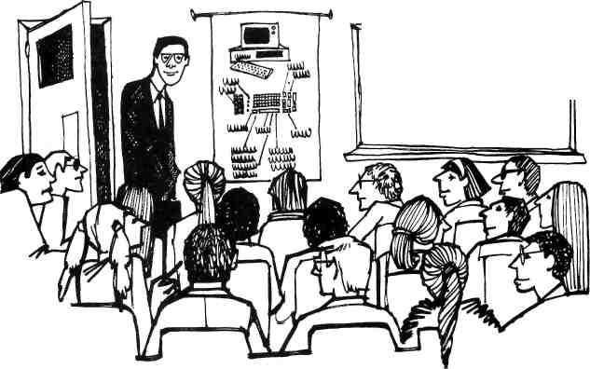
TRoFESgcR AKBRWS COMPUTER SCI 30t: INTRO TO BASIC PAgCM^ FORTRAN

Jane is interested in the subject because she cares for Information Sciences.
Paul is frightened. He spent his time at the disco last night so he is not ready for
the lesson. Nick is depressed because he doesn’t know the matter of discussion.
Mary is excited because she has found the answer to her question.
Ann is bored. She doesn’t take interest in the subject.

And you? Tell what makes you interested (bored, excited, frightened, depressed) in the medical school.
And how is Information technology connected with medicine?

12. Life of the medical school student is connected not only with
medicine and medical subjects. Students participates in activity of
different groups and societies.
Look through the steps of the table below and write the purpose
of each step taking into consideration work of your medical
school.

Step | Purpose
Forming an initiative group
Applying for grants
Forming a working group
Setting up a volunteers group
Implementing the project

13. Prove that at the medical school it is necessary to study not only
special medical subjects. Discuss your choice with other students.

14. Make the list

What qualities\ abilities and conditions help you to be more successful as a future medical worker.

Using What You’ve Learned

a) Make a description of yourself as a student of the medical
school.
b) Think of ways to improve yourself as a student of the medical
school.

Language support:

* that I will always
* I promise * that under no circumstances will I } be
* I solemnly undertake * that I will never do
* I swear * to be ... (adj.) ...

* I will * (to) be
* (to) do }...
* I’ll do my best * (to) become

c) Write three paragraphs describing your educational establishment
other entrants to be interested in. Use this scheme:

The features which make your medical school attractive.

The facilities your medical school can suggest
Advantages and disadvantages of your future profession

Раздел II. Development of Medicine.

Topic 3. Early Medicine.

1. Share your information by answering these questions about the
picture

- What is shown in the picture?
- Are any of these treatments useful?

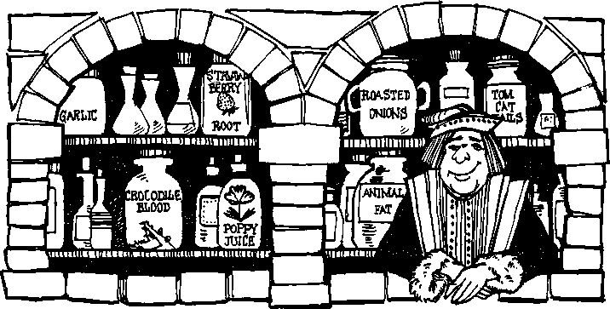

2. Study new words

- recent times - недавние времена
- barbers - парикмахер
- a guessing game - (зд.) нечто приблизительное
- remedy - лекарство
- poppy juice - сок мака
- animal fat - животный жир
- poor eyesight - плохое зрение
- bleeding - кровотечение
- a common practice - общая практика
- to let out ‘bad blood’ - выпускать «плохую кровь»
- skull - череп
- wound - рана
- to relieve pressure - облегчать давление
- incurable - излечимый
- drill - сверлить
- reliable science - надёжная наука

3. Read the text and say which of the following is true:

1 People believe medical myths
2. Medicine was a reliable science
3. Dangerous medical practices were commonly used.
4. There was nothing unusual in medicine of the Middle Ages.
5. Astrology and medicine were equal

Medicine and pharmacology are two sciences that have changed a great deal in recent times. Long ago, medicine was a guessing game. Medical care was given by doctors, pharmacists, and even barbers! All of them experimented freely on their patients, who often died as a result.
Early pharmacists depended on plant remedies that had been developed over the centuries. One popular remedy during the Middle Ages was poppy juice, which contains opium (a narcotic). Other remedies were animal fat and even crocodile blood, which was considered to be a "cure" for poor eyesight.
Other common practices were dangerous and sometimes fatal. For instance, bleeding patients to let out "bad blood" often resulted in the death of the patient. A common practice that was equally dangerous involved drilling a hole in the patient's skull. Perhaps this was done to treat head wounds or to relieve pressure inside the head.
People whose diseases were "incurable" often looked for help from the spirit world, astrology, and magic. Astrology, which was valued as a method of diagnosis, was even taught in many medical schools.
Medicine has become a reliable science only in recent times. Even now, however, it still involves a certain amount of experimentation.

4. Find in the text the following:
1. The description of fatal treatment
2. The things that can struck modern people
3. Drilling a hole in the patient’s skull was approved.
Work with grammar

Clauses with Who and Which. Replacement of Subjects

To form adjective clauses from simple sentences, who may replace subjects that refer to people. Which may replace subjects that refer to things or ideas.

Examples:

Two simple sentences: The physician was Dr. Andrews. He treated the
patient.

One complex sentence with WHO: The physician who treated the patient
was Dr. Andrew.

5. Use the cues to form sentences with adjective clauses with who.
Add a or an where necessary and use appropriate singular or
plural verbs in your adjective clauses.

examples: orthopedist / treat bone, joint, or muscle problems
An orthopedist is a doctor who treats bone, joint, or muscle problems.
orthopedists / treat bone, joint, or muscle problems
Orthopedists are doctors who treat bone, joint, or muscle problems.

1. radiologist / read / X-rays
2. surgeons / perform / operations
3. pediatrician / take care of / children
4. ophthalmologist / treat / diseases or injuries of the eye
5. internists / specialize in / diagnosis and treatment of diseases in adults
6. gynecologist / specialize in / functions and diseases of women
7. neurologist / take care of / patients with nerve or brain disease
8. psychiatrists / treat / mental problems

6. Use the following cues to form sentences with adjective clauses with
which (or that). Be sure to add articles where necessary.

example: rubber hammer / tool / be used for testing reflexes
A rubber hammer is a tool that is used for testing reflexes.

1. stethoscope / instrument / be used for listening to a person's heart
2. scalpel / instrument / be used for cutting during surgery
3. opium / narcotic / produce a feeling of great happiness
4. anesthetic / drug / put people to sleep before surgery
5. aspirin / drug / relieve pain
6. thermometer / instrument / measure temperature

7. Combine the following sentences about early medical practices with who or which. Make the second sentence of the two into an adjective clause when you combine them. Change words where necessary.

example: Some prehistoric people performed brain operations. These people lived in Europe in about 10,000 B.C.
Some prehistoric people who lived in Europe in about 10,000 B.C. performed brain operations.
These brain surgeons used simple knives. The knives were made of stone.
Many skulls have been found in Europe. The skulls had small holes cut into them.
The surgeons probably removed pieces of bone. They operated on the head.
In early times, however, some people went to magicians rather than doctors.
These people had physical problems.
People would ask for help from a magician. They thought spirits or magic caused
illness.
During the Middle Ages, some doctors used different cures. These cures did not treat
the body at all.
For example, a swordsman was not treated with medicine. The swordsman had been
hurt in a fight. (The sword was treated instead!)
Another remedy was to wear a card with the word "abracadabra" on it. This remedy
became very popular in the Middle Ages.
Clauses with Whose:
Replacement of Possessives

Whose may also be used to form adjective clauses. It does not act as the subject
of a clause. Instead, it replaces a possessive noun or adjective that modifies
the subject of the clause.
examples

Two Simple Sentences

One Complex Sentence with whose
The woman thanked the doctor. His treatment had cured her.

The woman thanked the doctor whose treatment had cured her.

8. Combine the following sentences with whose. Make the second

sentence into the adjective clause.

example: The villagers gave a gift to the pharmacist. His secret medicine had
cured their mysterious disease.
The villagers gave a gift to the pharmacist, whose secret medicine had cured their mysterious disease.
A person sometimes gets well unexpectedly. His or her will to live is very strong.
Another person might die unexpectedly. His or her belief in witchcraft is strong.
Some doctors can be successful. Their treatments are not always scientific.
Some people refuse to see a doctor. Their condition is serious.
People may be afraid of doctors. Their faith in modern medicine is not very strong.
Restrictive Versus
Nonrestrictive Clauses

In some cases, commas come before and after adjective clauses. Commas are used
with adjective clauses that give additional information. These clauses often modify
proper nouns (Dr. Nie, Athens, the Tower of London) or names of unique people,
places, or things (the sun, vitamin C, the equator). Who, which, whom, and whose
(but not that) may be used in these clauses. They are called nonrestrictive clauses.

In contrast, commas are not used with adjective clauses that specifically identify the

word(s) they modify. That may be used in this type of clause only; who, which,

, whom, and whose may also be used. These clauses are called restrictive clauses.

9. In the passage "Early Medicine" reread the sentences with

adjective clauses. Try to explain why commas are or are not used

with each clause.

10. In the following pairs of sentences, underline the adjective clause.
Then indicate whether the clause gives essential or additional
information. Next, add commas where necessary.

example: Typhoid and cholera, which have been common problems
for thousands of years, have now disappeared from some
areas.
(Additional information—commas are used.)
The bubonic plague which is a contagious disease is carried by rats.
This plague which was also called the "black death" killed half the population
of Europe in the fourteenth century.
Physicians who treated plague victims never found a cure for the disease.
During the plague, many people who touched the sick or the dead died after a
short time.
People who lived in major seaports were more likely to become plague victims.
Thousands of people died in Marseilles which was the major seaport.

11. Combine the sentences here and on the next page with who,
which, or whose. Change the second sentence into an adjective
clause. Be sure to use commas where necessary.

example: Mumps and chicken pox are not treated with antibiotics. They are diseases caused by viruses.
Mumps and chicken pox, which are diseases caused by viruses, are not treated with antibiotics.

1. Certain illness cannot be treated with antibiotics. These illnesses are
caused by viruses.
2. The ordinary cold is a viral infection. The cold is our most common
sickness.
3. A careful diet can be a good treatment for people. Their internal organs
do not function properly.
4. People can be treated effectively with drugs. These people suffer from
tuberculosis.
5. People must take hormone pills very day. Their thyroid glands have
been removed.
6. Many people take vitamin C every day. These people are trying to
avoid colds.
7. Antibiotics are chemicals. These chemicals are produced from
microorganisms.
8. Antibiotics can kill or control some bacteria. Some bacteria cause diseases.
9. Sir Alexander Fleming received the Nobel Prize in 1945. He discovered
penicillin.

12. Work in pairs and make two lists

What helped early pharmacists to treat  people | What helps modern medical workers  to treat nowadays

13. What in your opinion was the most dangerous in treatment
during the Middle Ages? Discuss it with your class mates

14. Read this extract from a medical newspaper article and be ready
to complete the mind map

Charaka (200 AD) the most popular name in Ayurvedic medicine was a court physician to Buddhist king Kaniska. Based on the teachings of Atreya, Charaka compiled his famous treatise on medicine, “Charaka Samhita”. Susruta of Benaras compiled his surgical knowledge in his classic 'Susruta Samhita' between 800 BC and 400 AD. Early Indians set fractures, performed amputations, excised tumours and repaired hernias.
Egyptian medicine dates from 2000 BC. The best known medical manuscript is
the Ebers Papyrus (1500 BC) which was found with mummy on the banks of Nile.
It contains 800 prescriptions with 700 drugs.
An early leader in Greek medicine was Aesculapius (1200 BC) whose daughter
Hygiea was worshipped as a goddess of health.
Hippocrates (460-370 BC) is described as father of medicine. He studied and
classified diseases. His famous oath is the basis of medical ethics of today. His
book Airs, Water and Places is considered a treatise on social medicine. He was
born in Greece.
Medical man of Rome (25 BC-50 BC) was Celsus who gave us the cardinal
signs of inflammation.
Another Roman medical scientist Galen (130-205 A.D.) was a pioneer of experimental medicine. He noted that diseases were due to three factors : (i) predisposing factors, (ii) exciting factors, and (iii) environmental factor, a truly modern fact. He was a medical dictator of his own time.
Arabs developed Unani system of medicine. Two arab physicians Rhazes (865-923) who differentiated between smallpox and measles and Avicenna (980-1037) who was the first to describe guineaworm.
Medicine was revived by Paracelsus (1490-1541) who publicly burnt the works of
Galen and attacked superstitions and dogma in medicine.
Fracastorious (1843-1553) enunciated the "Theory of contagion' and explained the
cause of epidemics. He became the founder of epidemiology.
Vasallus (1514-1564) did lot of dissection on human body and demonstrated
some of Galen's error.
Pare (1517-1590) revived surgery and became and father of modern surgery.
Fracastorius of Verona (1546) in his book on contagious disease pointed out that the agent of communicable disease was contagium vivum. He told that infection itself consists of minute particles, too small to be seen by naked eye. He further defined infection and expressed that infectious diseases were transmitted per contactum, by direct contact, per fonitem by fomites or inanimate objects.

A lot of  prejudice …… |  | The best known  Names ……

Modern medicine is based on ….. |  | Early medicine

Avoid treating….

Knowledge of Early medicine…. |  | If it were not for….. |  | We are obliged to remember…..

Using What You've Learned

Activity

a) Giving Definitions. In small groups, test your skills at a vocabulary game. The object of this game is for one person to describe people, places, objects, ideas, and so forth. The other people in the group must guess who or what they are. In this version of the game, the clues must include adjective clauses with that, who, which, or whose.
examples: a: I'm thinking of an instrument which is used to listen
to a person's heart.
b: A stethoscope.
a: I'm thinking of a physician whose specialty is treating children.
b: A pediatrician.

b) Read the two opinions on Early medicine.

Which of them do you share?

1. Early medicine is full of prejudices. And it must be excluded from modern

medicine.

2. Early medicine is a basis of modern medicine.

Join a group supporting one of the opinions. Add more arguments

to your part of the chart.

Topic 4. Medical Myths.

1. What are “medical myths”? How do such myths originate?
Share your ideas and opinions about the picture by answering
these questions

- What is shown in each part of the drawing?
- Does your culture have similar myths?

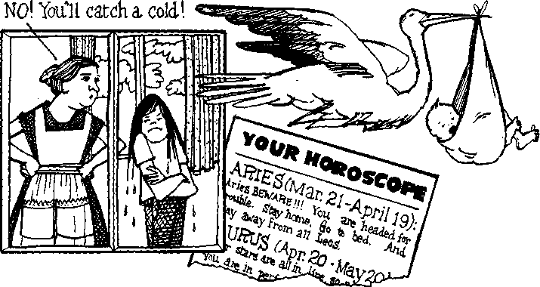

2. Study new words

- bubonic plague - бубонная чума
- to cause - вызывать, быть причиной
- arrow - стрела
- roasted onion - жареный лук
- aching ear - больное ухо
- a growth on the eyelid - нарост на веке
- misconceptions - неправильное представление, недоразумение
- to catch a cold - простудиться
- chill - дрожать
- germ - микроб

3. Make the plural form of the nouns and translate them. What origin
do some of the words have?

Earache, century, bacterium, germ, virus, cold, faith, people.

4. Read the text and do the tasks after the text

In the past, people believed a number of medical myths that we laugh at today. During the Middle Ages, for example, many people believed the bubonic plague was caused by arrows that Christ had shot. In the eighteenth century England, even people whom others considered sophisticated had faith in strange remedies. They believed they could cure an earache by sleeping with a roasted onion in the aching ear. The same people thought a growth on the eyelid could be cured by rubbing it with the tail of a male cat.
Since then, we have learned many things: bubonic plague is caused by bacteria, roasted onions cannot cure earaches, and cats do not cure growths. Nevertheless, there are medical myths that people still believe today. There are many misconceptions about the common cold, for example. People believe they will catch a cold if they sit in a draft or become chilled. Yet, we know a cold is due to a virus which is passed on through personal contact with people who have the germ. There is no myth about this!

5. Make these sentences interrogative and give an emotional colour
using the phrases To be honest…, It makes me feel…, Not to
mention the fact that…., Contrary to popular belief…., I feel very
strongly that…..

1. Many diseases are caused by bacteria.
2. We have learned about bacteria and germs.
3. People believed a great number of medical myths.
4. There were many misconceptions about origin of bubonic plague.
5. We know that virus passes from one sick person to another.

Work with grammar

Clauses with That and Which: Replacement of Objects
That and which may replace objects of verbs to form adjective clauses. Which refers
to things or ideas. That may refer to things, ideas, or people, although who(m) is
generally preferred for people. That may be used only in restrictive clauses (clauses
without commas) and is preferred in these clauses. Both that and which can also be
omitted from restrictive clauses.

Examples

Two simple Many people believe in predictions.
Sentences Astrologers make them.

One complex Many people believe in predictions that (which)
Sentence with astrologers make.
That or which.

One complex Many people believe in predictions astrologers make.
Sentence with
No relative
Pronoun.

Clauses with Who(m): Replacement of Objects Who(m) may replace
objects of verbs to form adjective clauses. Who(m) refers to people. In this type of
clause, whom is correct and preferred in formal English. However, who is very
frequently used, especially in conversation. Both who and whom can also be omitted
from restrictive clauses.

examples
Two simple The woman believed the astrologer. She had consulted him.
Sentences.
One complex The woman believed the astrologer who(m) she had consulted.
Sentence
With who(m).

One
Complex The woman believed the astrologer she had consulted.
Sentence
With No
Pronouns.

6. Underline the adjective clauses in the passage “Medical Myths”.
Indicate whether the clause is restrictive or nonrestrictive. Also
note whether the subject or the object of the original clause has
been replaced.

7. Add adjective clauses to the sentences. Use commas where

necessary. In sentences with restrictive clauses ( without commas ),

write both possibilities: using the relative pronoun and omitting it.

Remember that you cannot omit the relative pronoun from a

nonrestrictive clause.

example: Every society has myths, (which people believe in)
Every society has myths which people believe in. Every
society has myths people believe in.

- Many societies have a spiritual healer or magician, (whom everyone asks for medical advice)
- Medical practices differ from culture to culture, (that superstitious people believe in)
- Copper bracelets are also worn as jewelry, (which many people wear to cure arthritis)
- Amulets are necklaces, (which some people wear to prevent disease)
- One belief is that chicken soup will cure any illness, (that many Europeans and Americans have)
- In the past, the color red was never used in sick rooms, (which some cultures considered unlucky)

8. Combine the following sentences by using that, who(m),or which.
Use commas where necessary. For each sentence, write all
possible combinations. Then tell which sentences preferred in
formal English.

example: Many cultures still have healers or magicians. Sick people consult the healers or magicians.
Many cultures still have healers or magicians whom sick people consult. (Preferred in formal English.)
Many cultures still have healers or magicians who sick people consult.
Many cultures still have healers or magicians that sick people consult.
Many cultures still have healers or magicians sick people consult.
There are many medical myths. Even educated people believe them.
A common saying is "An apple a day keeps the doctor away." Mothers repeat this saying to their children.
Most of us think of doctors as special people. We can trust doctors with our most personal problems.
In many places there are no doctors. Sick people can consult doctors.
In my town there was one old woman. Everyone asked her about their health problems.
This woman always made herbal tea. She gave the tea to the sick.

9. Use the following cues to form questions with adjective clauses
beginning with who(m), which, or that. Work in pairs and take turns

asking and answering the questions. Many answers are possible.

example: medicine / you take most often

a: What is the medicine that you take most often?
b: Aspirin.
- doctor / you usually visit when you're sick
- foods / you eat when you have the flu
- fruit / you eat most often
- meat / you like the best
- mineral / you should take when you feel tired
- person / people in your family consult when they need medical advice
- food / you eat to live a long life
- food / people eat to have healthy hair and nails

10. Following the example as a model, use the cues to write definitions.
Add connecting words, articles, prepositions, and any other necessary
expressions.

example: flu / illness / many people get / in the winter
The flu is an illness that many people get in the winter.
- sugar / food / people eat for quick energy
- onion / food / some people eat to live longer
- black / color / Western societies associate with death
- mushrooms / plants / many people believe have mysterious powers
- storks / birds / many children believe deliver babies
- thirteen / number / many people believe is unlucky

11. Make up sentences of your own using the following.
To become chilled, to have germ, to catch a cold, to cure different diseases, to be caused by bacteria, through personal contact, misconceptions about.

12. Work in pairs and discuss the following

1.What problems do the medical myths cause ?
2.What are the roots of these problems?
3.Have you ever met people who believed different myths?

Exchange your impressions.

13. In groups discuss these statements and express your opinion by

giving your arguments. Try to persuade your opponents

Spiritual healers and magicians exist nowadays and many people consider them to be very helpful.

Only well-qualified medicine-workers can treat people

Using What You've Learned
Activity 1.
Comparing Traditional Beliefs.

Are there foods that people believe have special effects? For example, are there foods that make people live longer, have more children, see better, and so forth? Discuss these questions in small groups. Find out if there are foods that are recommended for a certain purpose in more than one culture. Does science support the idea that these foods are effective for these particular purposes?

Activity 2.

Describing Myths and Superstitions.

This activity concerns several "medical myths" and folk remedies that people have believed in. Look at the list of medical problems. Do you know any medical myths about their causes or cures? Where did you hear about them? In small groups, share your stories and information.
colds skin rashes
flu allergies
rheumatism headaches
hiccups depression

Topic 5. Changes in Medical Care

1. What do you know about medical care in other countries?
Share your ideas and experience by answering these questions
about the picture.

- What is sown in each picture?
- Why is hospital care so expensive today?

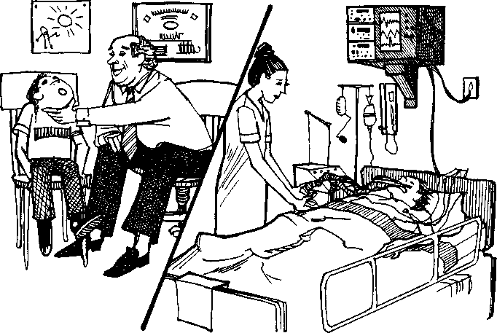

2. Study new words.

- expensive equipment - дорогое оборудование
- hospital stay - пребывание в больнице
- discovery - открытие
- facilities - оборудование
- bulb - лампа
- cardboard - картон
- guess - догадываться
- currant - электрический ток
- penetrate - проникать
- metal salts - металлическая стружка
- fracture - перелом
- to destroy cancer cells - разрушать раковые клетки
- laboratory assistant - лаборант
- available medical care - доступная мед. помощь
- health insurance - страховка
- private - частный
- small-pox - оспа
- typhus - тиф
- scarlet fever - скарлатина
- measles - корь
- to be widely spread - быть широко распространённым
- to be established - быть основанным
- disease prevention - предотвращение болезни
- scientific - научный

3. What do the words below mean in Russian?

Try and find a purely Russian equivalent

- advance
- bring back
- competitive field
- continued progress
- house-calls
- medical field
- protein
- through exposure to
- unthinkingly
- unwillingly

4. Study the meaning of the underlined words

  - Recent advances in medicine have raised moral questions.
  - The hospital has installed advanced equipment at enormous expense.
  - The World Health Organization has done a lot to advance medical problems and their solution.
  - Professor was teaching a course for advanced students of the Medical Academy.
  - He has received an advance on his salary.

5. Which of these questions from the list below you can answer
before reading the text?

1. How has medical science changed?
2. How is the physician’s office equipped?
3. Why do specialists work together?
4. How much time do the patients stay in a hospital?
5. What is the result of medical technology?

6. Read the text and say which of the questions from Ex. 2 you can
answer after reading.

Medical care has changed greatly since the days when the family doctor treated all family members for every type of medical problem. Today's physician is usually a specialist who treats only problems within his or her specialty.
Today's specialists often work together in a large group in order to share costs. The group will buy expensive equipment for its own offices rather than use hospital facilities. The physician's office usually has a laboratory where a variety of medical tests can be done. So, unlike the family doctor, who often visited patients at home, today's doctors normally see patients in their offices, where they can use specialized equipment.
Likewise, many changes are taking place in hospitals, where the cost of medical equipment and care is skyrocketing. Because of the high costs, patients now spend a limited number of days in the hospital, depending on their illness. Even new mothers, who used to have a five-to-ten-day hospital stay after the birth of their babies, are now being sent home in twenty-four hours.
Medical technology certainly has led to great advances in the diagnosis and cure of many illnesses. However, some people want to bring back the "good old days" when the family physician was also a family friend.

7. What was medical care like in the past? How is it different now?

Why? Are changes also taking place in our country? Why or why

not?

Work with grammar

Adjective Clauses with When and Where
When and where can introduce adjective clauses if they come after nouns. When
usually modifies a noun that has the meaning of time or a time period. Where
usually modifies a noun that has the meaning of a physical place or an abstract
area or field.

examples

Two simple The 1950s were a time. At that time, doctors still made house-
calls.
Sentences We can expect continued progress in the medical field.
New discoveries are made every day in the medical field.

One Complex The 1950s were a time when doctors still made house-calls.
Sentence
With When, We can expect continued progress in the medical field,
Where where new discoveries are made every day.

8. Combine the following sentences with when or where. Add

commas where necessary.

example: Treatment for cancer will be more effective in the future. In the future, scientists will know more about the body's immune system.
Treatment for cancer will be more effective in the future, when scientists will know more about the body's immune system.
- It's interesting to visit a hospital laboratory. In the laboratory, there is a lot of sophisticated equipment.
- Teaching hospitals often have the most modern facilities. In these hospitals, new doctors are educated and trained.
- We are now in an age. Medicine is very specialized.
- The doctor's office is now a complicated place. In the doctor's office, many tests and even surgery can be performed.
- Medicine will become a very competitive field in the future. In the future, there will be too many doctors in the United States.
- University hospitals around the U.S. are places. A great deal of research on cancer is taking place there today.
- The whole world is hoping for the time. A cure for cancer will be discovered then.
- We would all like to see the day. That day, good medical care will be available to everyone.

9. Complete the following sentences by adding adjective clauses
with when or where.

example: An intensive care unit is the place . . . where critically ill or injured
patients are cared for.
1. A hospital is the place . . .
2. Emergency room is the place . . .
3. A laboratory is the place . . .
4. The twentieth century is the time . . .
5. The Middle Ages was the time . . .
6. A pharmacy is the place ...
7. A nursing home is the place ...
8. Your visit to the doctor is the time . . .

10. Complete the following passage about traditional

medicine with the correct relative pronouns.

Tribal Medicine

In most areas of the world, people who are sick are taken to a doctor or a hospital
for treatment. But there are still many places -------------- patients are taken instead to a local medicine man, or healer, ----------------is a combination of doctor, priest, and psychologist.
In Western thinking, disease is something-------------------people regard as natural. In
tribal cultures, however, people consider illness an unnatural condition; it is a sign of
deep anger, hatred, fear, or conflict.
To discover the reason for an illness, a healer might use astrology or ask the patient
about his dreams. Once the cause of illness is known, the patient may go to a healing
shrine or temple, he cleans himself. After that, he
returns to the healer, performs different ceremonies to
chase the evil spirits out of the patient's body. The patient,------------- family also
participates in the healing ceremony, may be put into a trance,------------------- is a state of deep, unconscious concentration. While the patient is in the trance, the healer performs different ceremonies to chase the evil spirits out of the patient's body.
Finally, the healer suggests changes the person must make so that the
disease does not return.

11. Complete the passage using appropriate forms of the

verbs in parentheses. Choose from all tenses.

Changes in Medicine

Modern medicine began (begin) in the nineteenth century. At
that time, French physicians (develop) methods of clinical
medicine that we ____ (use) ever since.
There (be) many important landmarks from that time to
the present. A French physician, Rene Leanne, ---------------(invent) the
stethoscope in the early 1800s. Later, in 1842, a U.S. physician, Crawford Long, (anesthetize) a patient with ether. Painless operations
--------------(be) possible since that day. This---------------------------(be) the
beginning of modern surgery.
The science of how the body fights disease and infection
(interest) many medical scientists for hundreds of years. Louis Pasteur
first clearly (show) that bacteria cause disease, and Joseph Lister
(discover) that bacteria enter a patient during surgery,
explaining why so many surgical patients (die).

12. The discovery of the X-ray is one of the greatest changes in

medicine. Study the text and do the task after it

The Discovery of the X-ray.
Scientists working on a problem do not know and sometimes can't even guess what the final result will be. Professor Roentgen was a physicist at the University of Wartburg in Germany. Late on Friday, 8 November, 1895, he was doing an experiment in his laboratory when he noticed something extraordinary. He had covered an electric bulb with black cardboard, and when he switched on the current he saw little dancing lights on his table. Now the bulb was completely covered; how then could any ray penetrate? On the table there were some pieces of paper which had been covered with metal salts. It was on his paper that the lights were shining. Professor Roentgen took a piece of this paper and held it at a distance from the lamp. Between it and the lamp he placed a number of objects, a book, a pack of cards, a piece of wood and a door key. The ray penetrated every one of them except the key. This mysterious ray could shine through everything except the metal. He called his wife into the laboratory and asked her to hold her hand between the lamp and the photographic plate. She was very surprised by this request, but she obediently held up her hand for a quarter of an hour, and when the plate was developed there was a picture of the bones of her hand and of the ring on one finger. The ray could pass through the flesh and not through the bone or the ring.
At a scientific meeting where he described what happened, Professor Roentgen called this new ray "the Unknown", the X-ray. Doctors quickly saw how this could be used, and soon there were X-ray machines in all the big hospitals. At first the doctors didn't understand how powerful the rays were and many of them were injured, losing a finger or an arm through exposure to X-rays when they were using the machines. The most obvious use for this discovery was to make it possible for doctors and surgeons to see exactly how a bone was fractured. Other uses came later. It was found that these rays could be used to destroy cancer cells, just as they destroyed the healthy cells of the doctors who first used the machine. Methods were found later by which ulcers in the stomach could be located, and the lungs should be X-rayed to show if there was any tuberculosis present. "Mass X-ray" units are sent round to factories and detect early signs of trouble in the lungs.
Unfortunately for Professor Roentgen, whose discovery did so much for medical science, envious colleagues spread the story that he had stolen his discovery from a laboratory assistant who worked for him. He died, poor and forgotten, in 1923.

13. Quickly look through the list and mark the lettered phrase
nearest in the meaning to the word or phrase tested.
- Guess. 1. know for sure; 2. be in two minds; 3. suppose.
- At a distance. I. not very near; 2. very close; 3. a long way off.
- Mysterious. 1. hard to explain; 2. unexplainable; 3. easy to explain.
- Obediently. 1. unthinkingly; 2. unwillingly; 3. willingly.
5. Through in "through exposure to X-rays": l. with the help of; 2. in spite of;
3. as a result of.
6. Destroy 1. kill; 2. make useless; 3. break to pieces.

14. Briefly describe the experiment made by Professor
Roentgen.

15. Say whether, in your opinion, Professor Roentgen knew he was
going to discover the X-ray, or he discovered it by chance. Quote
facts from the text.

16. Look through the text once again, and select the statement which
best expresses its main idea. Explain your choice.
17. Sum up what the text has to say on each of the following points.
Discuss it with your class mates.
* How the X-ray got its name.
* How it happened that many doctors were injured through exposure to X-rays.
* The most important uses of the X-ray at the present time.

18. Read the texts and compare two systems of Public Health.

a) Public Health in the United States.
Health protection in America is not nationalized and there is no State public health in this country. Most of the clinics and hospitals Are private so everything should be paid for. People pay their own medical insurance and it's a person's will. For pensioners medical treatment is partly paid and for those who have no money there is Medicaid, it is a federal system of health insurance in the USA for those requiring financial assistance or in other words" medical + aid". It is paid by the State. Some people do not have insurance so they pay for all medical expenses, but sometimes your medical insurance is covered by your job. It depends on your work. In the past hospitals did not need in advertising but now people want to choose the best and the cheapest, because health service is very expensive. Much medical information is published in pamphlets and journals and some hospitals provide people with details of their services there. They print many articles about their work in order to compete with each other. For example, video-telemedicine service that is very useful and helpful in the work of the American doctors is explained in one of the pamphlets which is named "House Calls", and its advantages is also given here. In these article you can read the information about the doctors' private lives and their families, about new equipment, new methods of treatment and about different kinds of medical services. There are many clinics in the USA. A clinic is usually a group of doctors of different qualifications who join to work together. Each state has a Department of Health and they provide free service of inoculation for all people. And also the doctors can pay a house visit and examine the patients there. One of the American doctors says that although Americans pay high prices for medical help they can get excellent treatment.

b) Public Health in Russia

Health protection in Russia is nationalized. But there are some private hospitals and clinics there. Much attention is given to the health of population in our country.
In pre - revolutionary Russia the rate of mortality was very high, because of infectious diseases such as: typhus, small - pox, children diseases: scarlet fever, measles were widely spread. Epidemics carried away millions of people. Since 1917 care for health of the home population became one of major concerns of the government of Russia. A wide network of medical institutions was established in the country. Our clinics and hospitals are supplied with modern medical equipment. They don't limit their work to giving assistance to the patients who come to ask for advice, they pay great attention to disease prevention. The medical services are steadily expanding. A great number of hospitals, clinics, polyclinics, dispensaries, all kinds of laboratories and drug stores are constantly growing. There are many medical Universities, Institutes and medical colleges in our country now. There are local medical centers not only in every district in our towns and cities but at all big factories and farms as well. Various associations for the promotion of the public health are doing enthusiastic work. Thanks to our medical aid mass hygienic and educational work among the population is being conducted. There are no negative cases of any disease as it is checked at the very beginning. Thus prevention of infectious diseases is the main principle of the Russian medical service. Sanitary education helps greatly with the aim of prophylactics. Special institutions, controlled by the Public Health service help to solve problems of organization of sanitary education. The Russian government provides a wide network of health resorts for workers and their families, where they can undergo a course of treatment. Special attention is paid to the care of a mother and a child. The Ministry of Health directs all public health work. The center of the scientific medical thoughts is the Academy of Medical Sciences of Russia.

19. Write the table of comparisons of two systems. Mention all
advantages and disadvantages. Discuss it with your class mates.

Using What You've Learned

1) Playing the Dictionary Game. You will need a dictionary for this game. First, divide into groups of four. Take turns selecting a word from the dictionary. Choose a word no one in the group knows the meaning of. The person who chooses the word writes the correct meaning on a piece of paper. The other people write false definitions that they think "sound" real. Then the person who chose the word reads all the definitions aloud (without laughing!). Each person in the group votes for the definition he or she believes is correct. The object is to get your classmates to choose your definition rather than the correct one. You score one point for every person who voted for your definition.

2) Use of Adjective Clauses
Adjective clauses are frequently tested on standardized English proficiency exams. Review these commonly tested structures and check your understanding by completing the sample items on the next page.
Remember that. . .
- In object clauses, whom (not who) is grammatically correct.
- The original object is omitted in object clauses.
- The relative pronoun may not be omitted from a nonrestrictive clause.
- The verb in an adjective clause is singular or plural, depending on the word it modifies.

Part 1. Circle the correct completion for the following.
example: I have a friend-------------neighbours are from France.
a. that
b whom
c.whose
d. who
1. The doctor----------was a specialist in orthopedics.
a. that saw
b. whom I saw
c. who I saw
d. which I saw
2. Aspirin is a pain reliever---------- been used for centuries.
a. which it has
b. that it has
c. that has
d. that have
3. In traditional medicine, a healer is someone-----------may use a combination of rituals and remedies to treat a sick person.
a. whose
b. who
c. that
d. whom

Part 2. Circle the letter below the word(s) containing an error.

example: There are many languages used around the world today
A B
which they do not have a form of writing.
1. The system that it controls the flow of blood through the body is the
A B CD
circulatory system.
2. Over the centuries, three alcoholic liquids that has been used
a b c
as medicine are beer, brandy, and gin.
D
3. Aristotle, his writings about medicine were used by physicians and
A BC
barbers for hundreds of years, believed the brain to be a cooling
D
system for the heart.

3) Prepare for the Student Science Conference.
Prove that medical science has changed greatly since the Middle ages. Write a report which includes all the most outstanding facts.

Раздел III. Human Anatomy
Topic 6. The Human Body. Parts of the Body

1. Do you keep your body in good form?
What do you do for it?

2. Study new words

- body -тело
- head -голова
- hair -волосы
- face -лицо
- cheek -щека
- eye -глаз
- ear -ухо
- mouth -poт
- tooth-зуб
- arm -рука
- leg -нога
- hand -кисть (руки)
- finger -палец (руки)
- toe -палец (ноги)
- foot -стопа
- forehead- лоб
- nose -нос
- shoulder -плечо
- chest -грудь
- back -спина
- moustaches- усы
- eyebrow-бровь
- lip-губа
- chin-подбородок
- eyelashes-ресницы
- beard-борода
- neck-шея
- thumb-большой палец
- elbow-локоть
- waist-пояс, талия
- hip-бедро
- knee-колено

Internal organs:

- heart -сердце
- lungs -легкие
- tongue -язык
- pharynx -глотка
- esophagus –пищевод
- stomach -желудок
- liver -печень
- gall bladder -желчный пузырь
- pancreas -поджелудочная железа
- duodenum -двенадцатиперстная кишка
- small intestine -тонкая кишка
- appendix -аппендикс
- rectum -прямая кишка
- kidney -почка
- bladder -мочевой пузырь
- uterus –матка

3. Insert new words into the picture

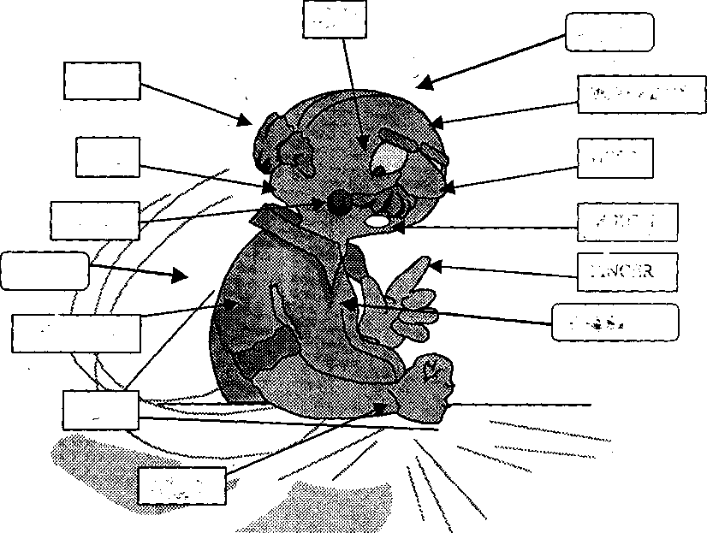

4. Fill in the gaps . Use the new words

The Human Body

The principal parts of the human body are the .... the ... , the..... . We speak of

the upper extremities ( arms ) and of the lower extremities (legs).

The head consists of two parts: the ... which contains the brain and the face which

consists of the .... the .... the ..., the ... with the lips, the ..., the ... and the ... .

The ear includes three principal parts: the external ear, the middle ear and the internal

ear.

The mouth has two lips: an upper lip and a lower lip. In the mouth there are ...

with ..., a ... and a ... . The head is connected with the trunk by the neck. The upper

part of the trunk is the ... and the lower part is the ... . The principle organs in the

chest are the ..., the ... and the ...(...). We breathe with the lungs and the heart

makes beats.

The principal organs of the abdominal cavity are the ..., the .... the ..., the ..., the ...,

the ... and the ... .

The upper extremity is connected with the chest by the shoulder. Each arm

consists of the upper arm, the forearm, the elbow, the wrist and the hand. We have

four fingers and a thumb on each hand.

The lower extremity consists of the hip, the ..., the ..., the ... and the foot. The skin

covers the body.

5. Look at the picture and share your opinion about appearance of the

couple.

Use adjectives:

- Long - oval - rosy - pale
- Handsome - ugly - healthy - slender
- Short - stout - blue - grey
- Dark - brown - straight - upturned
- Light - black - green - fair
- Round - broad - narrow - nice

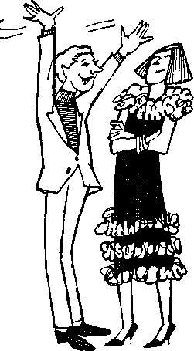

6. Discuss with your class mates
1. What are the principal parts of the body?
2. What does the head consist of?
3. What does ear include?
4. How do we call the upper and the lower parts of the trunk?
5. What are the principal organs of the chest?
6. What are the principal organs of the abdominal cavity?
7. What does each arm consist of?

7. In English, words connected with the body are often used in popular
idioms. Match the English proverbs with their Russian equivalents.
Comment on their meanings.

1. A bodyguard ---------- 1. Волноваться перед чем-либо
2. To get cold feet --------- 2. Одурачить кого-либо
3. To turn a blind eye -------- 3. Сильно рассердить кого-либо
4. To pull someone’s leg -------- 4. Держать язык за зубами
5. To be the apple of someone’s eye -------- 5. Одна голова хорошо, а две
лучше
6. To make someone’s blood boil ---------- 6. Не желать иметь дело с кем-
либо
7. A second-hand car ------------ 7. Телохранитель
8. To have one’s tongue in one’s cheek ----- 8. Проигнорировать кого-либо
9. To be all ears ---------------- 9. Боготворить кого-либо, быть
любимцем
10. Two heads are better than one --------- 10. Старая ( подержанная )
машина
11. To be two-faced ----------- 11. Весь внимание
12. To give someone the cold shoulder------ 12. Быть двуликим

8. Fill in the gaps in the story

Ned Clifton, the...-guard was beginning to get cold.... The reason was that he turned a blind... to the fact that a tall stranger had been pulling his... when he had told Ned that he was a veterinary surgeon who had come to see Abigail, the actress's dog. Abigail was the apple of Gloria's .... Any attempt to hurt her made the actress’s ... boil. Every day she took Abigail far a drive in her second... car. Few people recognized her in the old car.
Ned decided to take a second opinion , after all , two ... are better than one. He telephoned his friend Ken, also a ... guard to another famous film star, if he would help him to solve the "veterinary surgeon" problem. Ken said: "Your trouble is that you are too naive. You will believe anything. Don't be two... If you start deceiving her, she will give you the cold... and will get rid of you because she does not trust you". These were strong words. Ned rushed into the house. The actress was lying on the floor. Dead? No. She had fainted with a shock. The vet announced that the dog must have an operation. A real tragedy.

9. Look at the abdominal cavity. What organs belong to it?
Share your information with class mates.

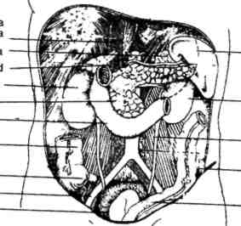

10. Read the extract from the Medical encyclopedia. In pairs discuss
the contents using special questions. Use the picture of the eye for
your conversation

.
Eye is an organ of sight and focuses an image onto the retina. Two eyes work in coordination under control of brain. Each eyeball moves by six delicate muscles. Eyeball has a tough outer coat the sclera. Sclera is a white portion of an eye.
The circular part of cornea is transparent and protrudes slightly. Cornea is main lens of eye and performs most of focussing.
Behind cornea is shallow chamber full of aqueous humour at the back of which is iris with its central hole, pupil. Pupil looks black and its size is altered with changes in light intensity. On the inside of the back of eye is retina, a complex structure of nerve tissue on which image is formed by the cornea.
The eyeball is sealed off from the outside by a flexible membrane called conjunctiva. The conjunctiva contains many tiny tear secreting and mucus producing glands.
Each eyelid contains about 30 meibomian glands opening along the lid margin behind the roots of lashes. Glands secrete an oil preventing lid margin to adhere during sleep.
11. You are a teacher of Anatomy. Be ready for your lecture translating sentences and signs to the picture from Russian into English and using the picture of an eye.
Лучи света попадают внутрь глаза через зрачок. Хрусталик, как объектив фотоаппарата, собирает лучи и фокусирует изображение на задней стенке глазного яблока, сетчатке. Сетчатка буквально напичкана светочувствительными рецепторами: палочками и колбочками. Благодаря палочкам мы различаем свет и темноту, с помощью колбочек воспринимаем цвета. Зрительный центр мозга сводит воедино и воспроизводит сотни отдельных деталей, ежесекундно запечатляемых глазом. На сетчатке возникает перевёрнутое изображение. Зрительный отдел мозга возвращает его в исходное положение.

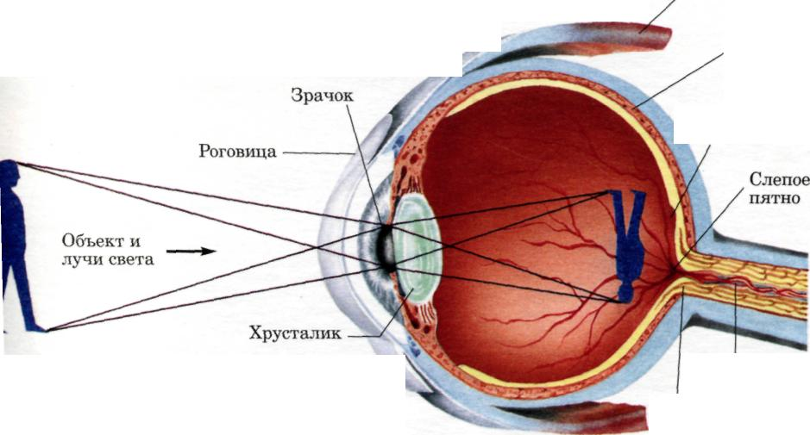
Глазная мышца
Кровеносные сосуды
Зрительный нерв

Using What You’ve Learned
Activity
- One of the students goes out from the class-room. When he comes in he must
guess the appearance of one of the students described by the other ones.
- Be ready for Student’s Conference. In the Medical Dictionary find
information about any organ and present your information.

Topic 7. Skeleton

1. Share your ideas about the saying
“Every family has a skeleton in the cupboard”

2. How would you translate the following passage from “The Final
Diagnosis” by A. Hailey? Does the phrase go out on a limb have
the direct meaning? Discuss it with your classmates

“That is good now.” O’Donnell decided to shelve his earlier doubts. If Orden
Brown had gone out on a limb like that, he would come through all right.

3. Study new words

abnormal-патологический, ненормальный
adult-взрослый
attachment-прикрепление
brain-мозг
cancer-рак
cause-причина, вызывать
common-распространённый, характерный
cranial-черепной
curved-изогнутый
damage-повреждать
decomposition-распад, разложение
excessive-излишний, чрезмерный
fibula-малоберцовая кость
framework-остов, каркас
graft-пересаживать (орган, ткань )
inhibit-задерживать, тормозить
joint-сустав
limb-конечность
marrow-костный мозг
rib-ребро
shin-голень
skull-череп
sternum-грудина
stiff-негибкий, окостеневший
thigh-бедро
vertebra-позвонок
vessel-сосуд
weight-вес

4. Read the following pairs of words in Plural and Singular forms

Singular: Plural:

sternum - sterna
vertebra - vertebrae
corpus - corpi
radius - radii

5. What are the nouns from which these adjectives are formed?

bony, cranial, facial, muscular, nasal, pelvic, osseous, skeletal, spinal, thoracic,
vertebral.

6. Compose pairs of synonyms

1. backbone a. clavicle
2. arm bone b. femur
3. breastbone c. fibula
4. finger bones d. foot
5. leg bone e. humerus
6. metacarpal bones f. hand
7. metatarsal bones g. phalanges
8. thigh bone h. spine
9. carpal bones i. sternum
10. collar bone j. wrist

7. Fill in the gaps of the chain

(n) bres...-...hig...-...i...-...ai...-...os...-.....xtremity
(v) perfor...-...en...-...amage
(a) crania...-...ight.

8. Give translation of the logical combinations of the word
“bone” with the following words

transplanted, broken, curved, deformed, damaged, enlarged, misshapen.

9. Look through the words and select the meanings to the figures

clavicle, femur, fibula, humerus, patella, radius, ribs, skull, sternum, tibia, ulna

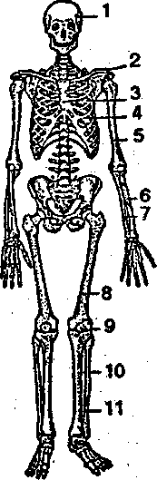

10. Look at the picture. Fill in the gaps using the following
adjectives:
cervical, coccygeal, lumber, sacral, thoracic

1.------------vertebrae
2.-----------vertebrae
3.------------vertebrae
4.------------vertebrae
5.------------vertebrae

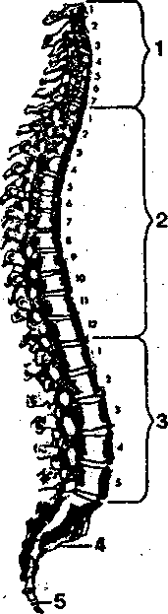

11. Choose the words from the list appropriate to the figures at the
picture. Discuss it in pairs.

humerus, collar bone, lower limb, metacarpus, phalanx, radial bone, shoulder blade, skull, sternum, ulnar bone, upper limb, wrist

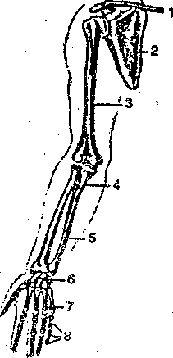

12. Select descriptions to the pictures and discuss it with your class
mates

- Ball and socket joint of hip - free movement

- Immovable sutures of cranium

- Hinge joint of knee - moderate freedom of movement

- Slightly movable joint of symphysis pubis

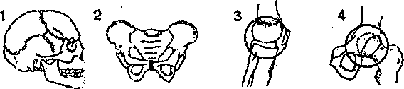

13. Read the text and do the tasks after it

The Human Skeleton

The human skeleton consists of more than 200 bones that are the organs of the skeletal system. The distribution of bones is as follows:
Skull-29 bones
Vertebrae-26 bones
Ribs and sternum-25 bones
Upper extremities-64 bones
Lower extremities-62 bones
Besides forming the framework of the body, the skeleton serves as a means of attachment for the skeletal muscles. It also protects delicate structures, such as the brain, the heart and the lungs. The marrow, or internal soft tissue, present in some bones is responsible for the formation of red blood cells (erythropoiesis) as well as the formation of certain kinds of white blood cells. Erythropoietic marrow is found only in the cranial bones, the vertebrae, the sternum, the hip bone, and the proximal ends of the thigh and arm bones. Bones also acts as a storehouse for calcium and phosphorus, releasing these minerals to the blood when they are needed.

14. Fill in the logical scheme of the content of the text

1. Composition (a) and Function (b-f)
a. Complete adult skeleton-206 bones
b.
c.
d.
e.
f.
2. Divisions of the skeleton
a. Axial skeleton-80 bones
1.
2.
3.
b. Appendicular skeleton-126 bones
1.
2.

15. Read the title of the text, its annotation and the text itself. Give
your own version of annotation. Prove your opinion to your class
mates

Заголовок. Mend one broken leg with the
other

Аннотация. An American surgeon has found the
way to replace the damaged bone
Текст. Sometimes broken legs don’t mend properly. This may be the result of bone cancer, or an accident which has damaged the soft tissue in the leg very badly. An American surgeon, Mr. Harold Dick, has found the way to avoid amputating the damaged leg – and even get the patient walking again quite normally. He takes the thin shin bone, the fibula, from the undamaged leg
and grafts it

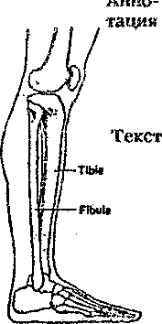
The fibula can be removed without affecting the leg

in place of the damaged bone. The fibula can be removed without affecting the good leg. The thin fibula isn’t strong enough to support the damaged leg immediately. The patient has to wear a splint for several month after the operation. The amazing thing, however, is that during this time the transplanted fibula grows in size until it becomes as thick as the damaged bone ( the tibia ) it has replaced.

16. Divide into two groups. You have two opinions on the text above. Support your group

17. Read the text “Great Music” and be ready to answer the
questions

* What were the diseases Rachmaninov suffered?

* What are the symptoms of “Marfan’s syndrome”?

* What were Rachmaninov’s hands?

Great Music

The opening chords of Rachmninov's second piano concerts are well known to music lovers. But for anyone who can read a score it soon becomes clear that the chords Rachmaninov wrote are. completely unplayable by anyone with normal-sized hands. Why did Rachmaninov write such unplayable music? The answer is that, for Rachmaninov, it wasn't unplayable. The distinguished pianist C.Smith, who knew the composer, described Rachmaninov's hands as being the largest he had ever seen.
According to Smith, Rachmaninov could play with his right hand a chord of С with an extra E at the top. This is hard enough for most people, but Rachmaninov could do it using his thumb to play the middle E. He could twist his thumb between his fingers in a way impossible for normal people. Medical researchers think Rachmaninov may have suffered from a hereditary disease, now called Marfan's syndrome. It is a rare disease of connective tissue, which can affect the skeleton, eyes, heart and blood vessels. The most marked symptom is excessive bone growth- leading to long limbs and fingers. The composer was known to suffer from back pain and stiff joints, other symptoms of this disease. Rachmaninov's appearance was characteristic of a sufferer from Marfan's syndrome. He was tall and slender and had a long thin nose and prominent ears. His huge head may have contributed to his art. But Rachmaninov's genius doesn't seem to lose much, if anything, when interpreted by pianists with normal-sized hands.

18. Read the article from the American newspaper and write out
key-words by the parts of the speech – 5-7 verbs, 5-7 nouns.

Health in Space
Long-term space flights could lead to health problems when astronauts return to the Earth.
Russians hold the record for spending the longest time in space. They have also spent the most time experimenting on the ability of humans to survive long periods in the confined and weightless conditions of space travel. The recent results of a joint US/Soviet experiment with rats identify loss of bone strength and muscle power as a serious problem. The loss measured in the animals after only two weeks in space was an alarming 40 per cent. This loss was principally in the weight-bearing and postural muscles of the back and leg which, in normal conditions, keep the body standing. A similar weakening of the heart muscle could make it impossible to return to Earth after a long period in Space.
During space flights, astronauts follow vigorous exercise regime to try and prevent bone and muscle loss. This seems to work well on muscles but it is not so successful at stopping bone loss. The US/Soviet experimenters think that weightlessness in Space inhibit the growth hormones that usually stimulate bone formation to balance the bone decomposition that takes place all the time. They are confident of finding a solution to bone loss. This would not only make long duration space flights possible but would also help solve problems on the ground, such as osteoporosis or bone loss common in older women.

19. Choose the proper annotation to the text (two annotations are
not correct). Prove your answer to your class mates

A. The longest manned space flights today last over a year. Scientists are still studying the effects of such long periods in the confined and weightless conditions in Space on the human body. The main problem is weakening of the bones and muscles. Vigorous exercise during space travel solves the problems. The heart is a vital muscle. Astronauts could die on return to Earth after years in Space if this muscle was too weak.
B. Space flights are getting longer. Research shows that prolonged
journeys in the confined and weightless conditions of Space cause problems of bone loss and weakened muscles in rats and humans. Scientists hope to find a solution which will enable astronauts to spend longer in Space and will help with earth-bound problems, such as osteoporosis.
C. Scientists researching into problems of bone loss and weakened muscles resulting from the restricted conditions and weightlessness in space travel hope to help ordinary people suffering from problems such as bone loss (osteoporosis) common in older men. From research with rats, they think that weightlessness inhibit the growth hormones that usually stimulate bone formation. A joint US/Russian team is confident of finding a solution to the problem.

20. Work in pairs and discuss the following
1. What is the skeleton?
2. How many bones are there in the skeleton?
3. What is the skull?
4. What vertebrae are there in the spine?
5. What groups are the bones divided into?

Using What You’ve Learned

Choose any sentence you like and give more information
on it

- Sometimes broken legs don't mend properly.

- Marrow is found only in the cranial bones, the vertebrae, the sternum,

the hip bone and the proximal ends of the thigh and arm bones.

- The most marked symptom is excessive bone growth.

- There is abnormal cartilage growth.

- An American surgeon has found a way to replace UK damaged bone.

b) Give annotation to the text in written
Man is the only animal that walks erect. He is the only animal in whom old age brings a forward bending of the spine. There are definite physiological results of maintaining an erect spine. The mechanical arrangement of the spine itself is such that if it is held erect the important nerves that radiate to all parts of the body from this central "bureau" are able, to perform their functions more perfectly. When there is pressure on these nerves there is found to be imperfect functioning. The affected organs will not work normally. There is another way in which an erect carriage has a direct physical influence, viz., in maintaining the proper position of the vital organs. When the body is held erect the chest is full, round and somewhat expanded affording plenty of room for the heart and lungs. The stomach, liver and intestines all tend to drop or sag below their normal position when the body bends forward and the functioning of these organs is very much impaired.

a)You are a teacher of Anatomy. Ask your students about:

- the function of the bones
- the bones of the upper extremities
- the bones of the low extremities
- the function of the marrow
- the number of the bones at all

Topic 8. The Major Systems of the Body

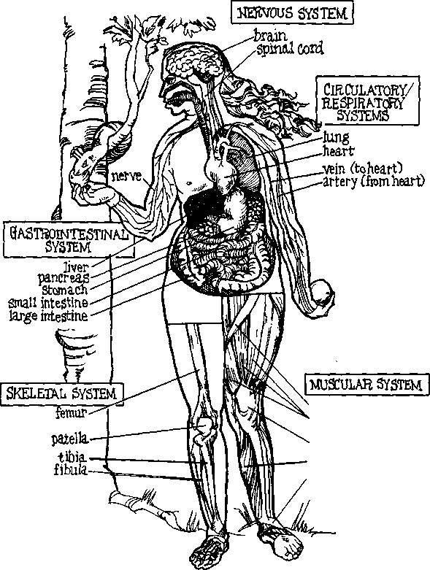
sartorius quadri
ceps
tendon
gastrocnemius
ligament

1. Study new words.

- Skeletal - скелетный
- muscular - мышечный
- digestive - пищеварительный
- respiratory - дыхательный
- urinary - мочевой
- endocrine - эндокринный
- reproductive - репродуктивный
- structural - структурный
- alimentary - пищеварительный
- spinal cord - позвоночный столб
- ligament - связка
- cartilage - хрящ
- discharge - удалять, выводить из организма
- urinary bladder - мочевой пузырь
- hormone - гормон
- join - связывать
- vessel - сосуд

2. What do you know about the way your body works?
Share your ideas and opinions by answering the following
questions about the picture.

* What are the major systems of the body?

* How does your blood move through your body?

* What are nerves? Do they extend throughout your body?

3. Read the text and do the tasks after the text

The Major Systems of the Body

During the last one hundred years, medical researchers have discovered a great deal
about the way the human body works. We now know about the various systems of the
body that keep us alive. The systems that are most important include the circulatory,
respiratory, nervous, musculoskeletal, and gastrointestinal systems. Each of these
systems controls major body functions. The system that controls the flow of blood
through the body is the circulatory system. It includes the heart, the arteries, the
capillaries, and the veins. The nervous system connects the brain to the rest of the body
through the spinal cord and the nerves.

The system that supports the body and allows it to move is the musculoskeletal system.

The system that controls breathing is the respiratory system. It includes the nose, mouth,

throat, trachea, bronchi, and lungs. Finally, the gastrointestinal system, the part of the

body that controls digestion and elimination, consists of the esophagus, the stomach,

and the small and large intestines. Two of its most important organs are the liver and is

the pancreas.

4. Quote the sentences in which the following words and word
combinations are used in the text.

The way the human body works, the various systems, that are most important, major
body functions, controls the flow of blood, to connect the brain to the rest of the
body, to support and allow it to move, to control digestion and elimination, to control
breathing, most important organs.

5. Make up sentences using the following words.

- the, system, begins, digestive, mouth, the, with.
- function, to remove, major, the, of, urinary, the, system, urine, is.
- is, the, system, of, complex, one, the, nervous, most, systems, all, of, body,
human.
- lymph, are, blood, and, the, tissues, body, of, liquid, the.
- Includes, muscles, the, and, musculoskeletal, the, system, bones, joints.

6. Insert the missing words given below.

- Another important function is to maintain the … balance of water, salt, and
acid in the body liquids.
- The brain is the … centre for regulating and coordinating body activities.
- Respiration is the … process of breathing.
- The blood and lymphatic systems have many … .
- Joints are the places where … come together.
- The endocrine system is composed of … located in different regions of the
body.

(main, proper, functions, mechanical, bones, glands)

7. Discuss the following:

* Which system connects the brain to the rest of the body?
* What system includes the liver and the pancreas?
* What does each of the following systems do: circulatory, respiratory, nervous,
musculoskeletal, gastrointestinal?

Work with grammar

Clauses with THAT: Replacement of Subjects

To form an adjective clause, that may replace the subject of a simple
sentence. It may be used to refer to ideas, things and people. Note that
who(m) is usually used for people, however.

examples
Two The body is like a complex machine. This machine automatically
Simple repairs itself
Sentences

One The body is like a complex machine that automatically
Complex repairs itself.
Sentence
With that

8. Underline the adjective clauses (that clauses) in the opening

passage, "The Major Systems of the Body." Circle the words

that the clauses modify.

9. Combine the following sentences. The second sentence should
become a clause beginning with that. Omit words and change a or
an to the where necessary.

example: Blood is a liquid. This liquid circulates through the body.
Blood is the liquid that circulates through the body.
1.The heart is an organ. This organ pumps blood through the body.
2.Blood is a liquid. This liquid carries food and oxygen through the body.
3.Blood is carried in vessels. The vessels are called arteries and veins.
- The lungs are filled with air. This air contains oxygen.
- The body is supported by a bone and muscle structure. This structure is
responsible for body posture and movement.
- The body is covered with skin. The skin protects the body from bacteria.
- The brain is the control center for the nerves. The nerves carry messages to
and from the body.
8. Digestion of food is an essential process. This process is taken place in the
intestine.

10. Combine the following sentences to form one sentence with a
clause with that. Omit words where necessary.

example: In Ancient Egypt, there were many doctors. These doctors cured patients with the help of magic and spirits.
In Ancient Egypt, there were many doctors that cured patients with the help of magic and spirits.
- Egyptians believed sickness came from spirits. These spirits were angry
and evil.
- The Egyptian doctor would put a magic spell on the angry spirit. This
spirit had caused the person's illness.
- The magic spell always included words. The words had to be repeated in a
certain way.
- Egyptian doctors also used medicine. This medicine came from the organs of
wild animals.
5. In addition, these doctors used a large number of drugs. These drugs
included minerals, vegetables, and even beer.
6. The ancient Greeks practiced a different kind of medicine. This kind of
medicine was based on the study of symptoms.
7. Ancient Greek doctors trained in medical schools. These schools were
located all over Greece.
8. Aristotle, the famous Greek philosopher, wrote three important books.
These books discuss medical problems that we still face today.

11. Adjective clauses with that are often used to define words. Use
the following cues to define various parts of the body. Be sure to
use appropriate singular or plural verbs in the adjective clauses
and to add articles or pronouns where necessary.

example: heart / organ / pump blood / through / body
The heart is the organ that pumps blood through your body.
- spine / set of bones / support / body
- arteries / major blood vessels / carry / blood away from / heart
- spinal cord / set of nerves / lead to / brain
- nerves / fibers / communicate messages to and from / brain
- knees / joints / allow you to bend / legs
- tendons / tissues / connect muscles to / bones
- Quadriceps / muscle / extend the leg
- Femur / bone / reach from the hip to the knee

12. In pairs, use the diagram at the beginning of the chapter to
help you to make definitions of the following terms. Complete each
sentence in column A with one of the items in column B.

example: Your brain is the organ that controls the body through nerves.
а в

1. Your brain is the organ a) that carry blood back
to the heart
2.Your heart is the organ b) that brings oxygen to
your blood
3.Your lungs are the organ c) that controls the body
through nerves
4.Your intestine is the organ d) that connects the upper
arm and forearm 5. Your bones and muscles
are the structures e) that digest your food

6. Your arteries are the blood vessels f) that carry blood from
your heart to your organs

7. The veins are the blood g.) that receives
vessels food you eat

8. The elbow is the joint h) that support the body
and provide movement

9. The pancreas is the organ i) that pumps blood through
the body

10. The stomach is the organ j) that makes insulin

Using What You’ve Learned

1. Giving Definitions. Try to give definitions of the following

body parts, as well as four or five others that you may choose.

1. ankle 4. ear 7. lips
2. eyebrow 5. wrist 8. hand
3. nose 6. teeth

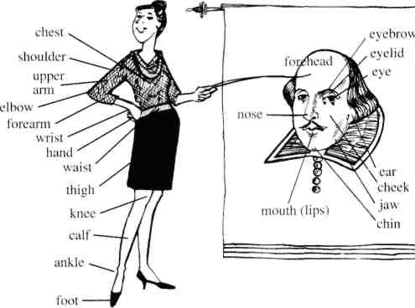

2.Fill in the table below and tell about body systems, their organs and functions. Use the anatomy plates from the application №7.

Systems | Organs | Function(s)

Topic 9. Cardiovascular System

1. Study new words

Ability n | способность
advantage n | преимущество
aorta n | аорта
arteriole n | артериола
artery n | артерия
atrium n | предсердие
average a | обычный, нормальный, средний
capillary n | капилляр
chamber n | камера
circulation n | кровообращение
coat n | оболочка, слой
congest v | накопляться
demand n | потребность
deprive v | лишать чего-либо
distribute v | распределять
efficiency n | действенность
exchange n | обмен
enter v | поступать, входить
evolve v | развиваться
exercise n | упражнение, тренировка
failure n | отсутствие чего-либо, недостаточность
filling n | наполнение
fluctuation n | колебание, флюктуация
invertebrate n | беспозвоночное животное
kidney n | почка
line v | выстилать
node узел
nourishment питание
outfit снабжать
output выброс
oxygen кислород
pacemaker водитель ритма
pump насос
septum перегородка
rate частота, скорость
suction всасывание
ventricle желудочек

2. Read the following pairs of words and translate them.

advantage | advantageous
aorta | aortic
artery | arterial
atrium | atrial
circulation | circulatory
health | healthy
node | nodular
septum | septal
valve | valvular
ventricle | ventricular
vertebrate | vertebral
vein | venous

3. Read and translate the words and word combinations.

Chamber: the heart consists of two separate chambers; the right atrium and
the right ventricle are the right chamber.
Thick: a thick wall; thick layer; the walls of the left atrium are thick; the left
ventricle has thick walls.
Pulmonary: pulmonary artery; pulmonary circulation; pulmonary disease;
pulmonary function; pulmonary valve.
Dilate: dilated; to be dilated: the vessels dilate: the heart dilates and
contracts.

4. Match the columns to find correct explanation and translate
them

1.At heart ( or in one's heart of hearts) crush him with grief
2. (Be) sick at heart In one's inmost feelings
3. Break somebody's heart oppressed with grief or despair
4. Take something to heart show one's feelings for all to see
5. Open (uncover) one's heart to somebody cheerfully, free from sorrow
6. Search one's heart heavily, with sorrow
7. With a heavy heart examine carefully one's
own beliefs and conduct

8. With a light heart expand or enlarge it
9. Wear one's heart on one's sleeve consider seriously
10. Lose heart be hard-hearted enough (to do )
11. Not to have the heart lose courage
12. Take heart with all one's energy and devotion
13. Heart and soul cheer up

5. Do you remember the Latin language? Translate the following

English words

vascular
interspace
atrium
fibrous
pericardium
costal
ventricle
systematic
apex
septum
valve
pulmonary

6. Translate explanations, make up scheme, entitle it
and give definitions in Russian

A-Heart
B-Pulmonary Arteries
C-Systemic Veins
D-Pulmonary Veins
E-Systemic Arteries
F-Lung Capillaries
G-Systemic Capillaries

Scheme 1.
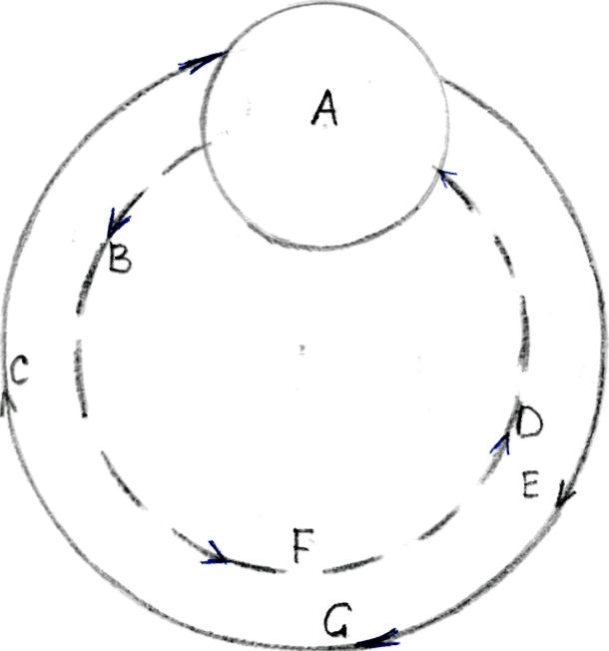

7. Decipher abbreviation to the scheme 2

RA

LV

RV

LA

LV

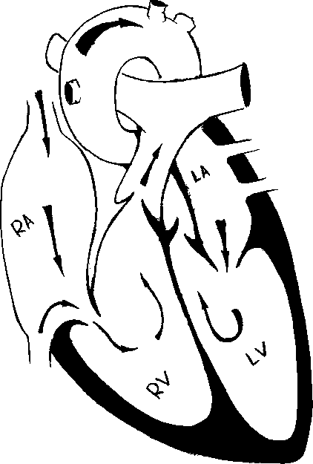

Scheme 2.

8. Add definitions to the scheme 3 with the following adjectives:
Aortic, interior, left, mitral, right, superior, pulmonary, tricuspid.

Work in pairs. Make up a short conversation on the scheme

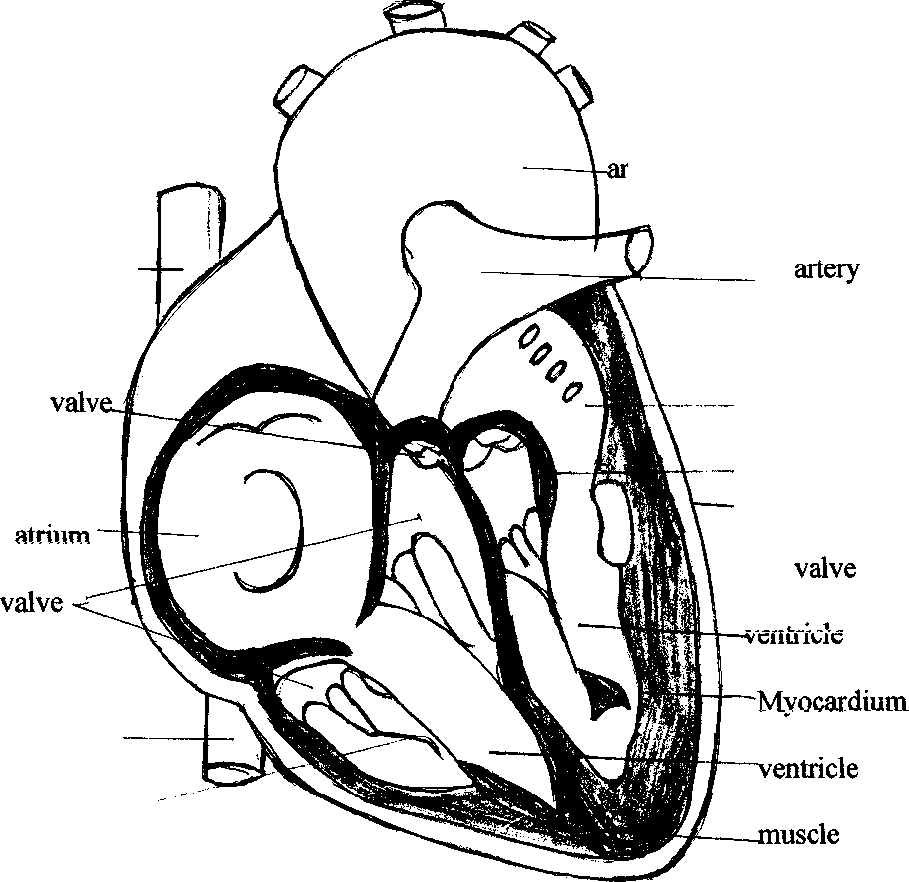
ch of aorta
vena cava
—-atrium
valve Pericardium
vena cava
Chordae tandinae

Scheme 3

9. Put the predicates into the following sentences to the scheme 4

Predicates: prevent, enters, separates, carries, are gathered, is, passes,

has, is pumped

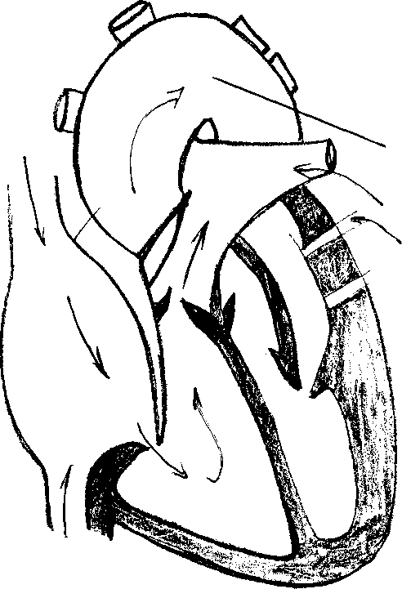
Blood from head, neck, arms
Aorta
Pulmonary artery
Blood from lungs

Blood from trunk
and lower limba

Scheme 4.

1. The heart four chambers.
2.The tricuspid valve..............the right atrium from the right ventricle
3. The mitral valve the left atrium from the left ventricle.
4. These valves to the papillary muscles by fine tendons.
5. The valves regulation of blood from the ventricles to the atria.
6. The aortic valve and the pulmonary valve….. regurgitation of blood from
the arteries into ventricles.
7. From the superior and interior vena cava blood....... the right atrium
and....through the tricuspid valve into the right ventricle.
- From the right ventricle blood.... through the pulmonary valve into the
pulmonary artery.
- The pulmonary artery the only artery which
deoxygenated (“venous”) blood.

10. Insert the necessary words given below.

- The aorta … from the upper part of the ventricle.
- The shape of the vessels … when they dilate.
- The right lung is … than the left one.
- The lungs are … with the pleura.

(varies, covered, extends, heavier)

11. What is the meaning and function of the words 'examined',
'changed' in each sentence. Translate them

A 1. The therapeutist examined the patient yesterday.
2. The patient was examined by the therapeutist attentively.
3. The patient examined by the therapeutist yesterday felt bad.
4. The examined patient was ill with a heart disease.
B.1. The doctor saw the changed condition of the patient.
2. That was why he changed the administrations (назначения) to the
patient.
3. The administrations were changed to restore his health rapidly.
4. The nurse did not forget to carry out the administrations changed by
the doctor.

12. Read the text and the tasks after the text

Evolution of the Heart
Beginning with the invertebrates, the lowest members of the animal kingdom, the heart is a simple propulsive muscular tube. In the fish the heart has evolved into a chambered organ with an atrium, or receiving chamber, and a ventricle, a thick-walled pumping chamber. This development was necessary because the vertebrates, of which the fish are the lowest class, have a more complicated structure and are generally large than the invertebrates, and require more oxygen. With the development of lungs in the higher vertebrates, the atrium became divided into two parts by the formation of a dividing wall called septum. Thus, in man and other animals with a four-chambered heart, blood from the body cells enters the heart at the right atrium, and from here it passes into the right ventricle from which the blood is pumped through the pulmonary artery towards the lungs. The oxygenated blood is carried back to the heart through the pulmonary veins, which empty into the left atrium. From the left atrium, the blood passes into the aorta for the distribution throughout the body.
13. Choose five nouns from the text which characterize the heart and compose three sentences of your own. Consult with anatomy plates (see the application №7). Discuss it with your class mates
14. Give definitions of the following terms.
E.g.: The heart is a pumping organ.

Atrium,

ventricle,

septum.

15. Answer the questions using this scheme

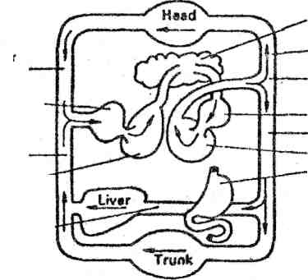

Lungs
Carotid and vertebral arteries
Aortic arch
Left atrium
Aorta
Left ventricle
Gastrointestinal
tract
Superior vena cava
Right atrium
Interior vena cava
Right ventricle
Portal vein

1. How many circulatory systems are there in the body?
2. What does the systemic circulation supply?
3. What is the main function of the pulmonary circulation?
4. What organs receive arterial blood?
- What vein do the gastric, splenic and mesenteric veins return blood into?
- Where does the portal vein go to?
- What does the portal vein break up into?
- Is the blood from the liver capillaries collected into the hepatic vein?
- What blood supply does the liver have?

16. Analyze the following sentences in pairs
1 . The invertebrates are the lowest members of the animals.
2. The fish are the lowest class of the invertebrates.
3. The vertebrates have a more complicated structure and are generally larger
than the invertebrates, and require more oxygen.

17. Listen to the text.
The Human Heart.
The bigger person, the bigger the heart. Thus, there is the great variation in the size and weight of the human heart. The normal weight of the heart in both children and adults is approximately half of one per cent, or a little less, of the total body weight. The professional athlete's heart is a little heavier, with slightly more muscle. Just as the size and weight of the heart vary, so does the rate at which the heart beats. In some persons, especially trained athletes, the heart beat may be as slow as 45 beats per minute, when the person is at rest. Under the stress of vigorous exercise, the heart rate may reach as high as 170 or 180 beats per minute. The normal heart beat is considered to be about 72 beats per minute. At this average rate the heart contracts 4.320 times in an hour, 103.680 times in a day, 58.597.200 times in a year, and 4.100.544.000 times in a lifetime of 70 years.

18. Give the English equivalents of the following Russian words and expressions and quote the sentences with them.

- человеческое сердце
- вес сердца
- взрослый человек
- мышцы
- процент
- биение сердца
- 45 ударов в минуту
- человек на отдыхе
- сокращения сердца

19. Discuss the following in your group
- What is the size of the human heart ?
- What is the normal weight of the heart?
- Whose heart is heavier?
- What is the normal heart beat ?
- How many times does the heart contract in an hour?

20. Compose the sentences from the words.
1. acts, The, pump, a, heart, as.
2. the, doctor, out, varying, pulse, in, John Floyer, an, men, rate, the, English,
was, scientist, to, first, find.
3. tons, blood, pumped, the, daily, Ten, of, are, through, heart.

21. Translate the sentences into English.
1. Физиологи определили, что у взрослого сердце совершает от 60 до 72 ударов в минуту.
2. Исследовательская работа показала, что уровень сердечных ударов возрастает в зависимости от различных эмоций.
3. За каждым ударом сердца следует пауза.
4. Каждое сокращение и пауза составляют сердечный цикл.
5. Каждый сердечный цикл состоит из трёх фаз.

Using What You’ve learned

Give a summary of the texts "Evolution of the Heart"
and "The Human Heart”. Tell about the work of the heart using the
plate №2 from the application 7.

Раздел IV. Diseases
Topic 10. Ulcer

1.What do you know about ulcer? What are the symptoms of it?
Share your knowledge with your class mates

2. Study new words

stomach-желудок
to be responsible for-быть ответственным за
pancreas-поджелудочная железа
perforation-прободение
urgent-срочный
affect-влиять, воздействовать
heredity-наследственность
nourishment-питание
vomiting-рвота
initial-первоначальный
heartburn-изжога
belch-отрыжка
constipation-запор, констипация, обстипация
complication-осложнение
keep on a diet-быть на диете
worsening-ухудшение

- Review the words. Make up the words

* perfo - ach
* consti - ment
* respon - pation
* nourish - ration
* heart - sible
* stom - burn
* pres - sure

- Read the text and compare ulcer with gastritis fulfilling the table. Use
Text 11. from “Texts for additional reading” if necessary. Add
information about treatment of ulcer after doing Ex. 8

Ulcer |  | Gastritis
Symptoms | Treatment | Symptoms | Treatment

Ulcer
Ulcer is a chronic disease which affects the person’s stomach. Factors which contribute to ulcer are as follows: heredity, bad nourishment, drinks, smoking. They also say, that such bacteria as Helicobacter Pylori is responsible for ulcer too.
The main symptom of ulcer is a pain in the pancreas. The pain is felt periodically in autumn and in spring. It disappears after vomiting and after warming up the area. Initial pains (thirty or forty minutes after a meal ) help to discover ulcer in the stomach.
Besides pains, there are some other symptoms of ulcer: vomiting, heartburn, belch, constipation. It is necessary to X-ray a patient to make a correct diagnosis. There may be some complications, bleeding, for example. When there is bleeding in stomach, blood pressure falls, a patient feels very weak and suffers from headaches. In case of perforation a patient feels a very sharp pain. An urgent operation must be performed.

5. Fill in the gaps using the text

1. Heredity, bad nourishment, smoking and drinks.............to ulcer.
2. Pain in the pancreas...........of ulcer.
3. Vomiting, heartburn, belch and constipation.........of ulcer.
4. It is necessary to..........a correct diagnosis.
5. ..................complication of ulcer.
6. In case of...........sharp pain.
7. Ulcer..........disease.

6. Choose the correct version

1. Ulcer is a chronic disease of the
a) head
b) teeth
c) stomach

2. Helicobacter Pylori
a) develops ulcer
b) complication of ulcer
c) is a chronic disease

3. When the person has bleeding
a) he feels very strong
b) blood pressure falls
c) he goes shopping

7. Compose the sentences from the words

1. of, Ulcer, diseases, the, is, chronic, one
2. be, case, operation, In, of, performed, must, perforation, urgent, an
3. doctor, a, diagnosis, X-ray, wants, If, to, necessary, a, make, patient, correct, is, to, it
4. ulcer, factors, to, disease, Many, contribute, chronic
5. warming, Pain, after, disappears, up, area, pancreas, the, in, the
8. Discuss the text about treatment of ulcer
Add more recommendations using knowledge of the subjects
Pharmacology and Non-traditional methods of treatment

Ulcer must be treated with medicines. A patient must keep on a diet, physiotherapy must also be used. A nurse must see to it that a patient should be comfortable both physically and psychologically. A patient must follow the diet number one.
He mustn’t smoke and drink. A nurse plays an important role in preparing patient for different laboratory analysis. If a nurse notices some complications of the disease or the worsening of the patient’s health, she must immediately inform a doctor about it.
A nurse’s high professional training, attentive attitude to the patient and the doctor’s instructions will be able the patient to be cured from the disease.

9. What questions would you ask to get such answers?

1. .......? Many factors are responsible for good treatment of the patient.
2. .......? A patient must follow all doctor’s instructions
3. .......? A patient must follow the diet number on
4. .......? If a nurse see some complications of the disease.
5. .......? Ulcer must be treated with medicines

- Study recommendation for the patient with peptic ulcer and say
which of them you find unusual, difficult for execution and
wrong

The patient of peptic ulcer should avoid
* excessively sour, salty or spicy foods
* coarse food such as raw vegetables, fruits with seeds and skin.
* excessively hot drink/food
* smoking, alcoholic beverage and aspirin should usually be avoided.
* meat should consist of small servings. Try to eat about the same amount at each meal.
* peptic ulcer is one disease where proper dietary management is equally or more rewarding than pure drug therapy.
Proteins
Normal protein requirement of 1 g/kg body weight, i.e. about 60 gm should be
given. Milk proteins will not irritate gastric mucus. Meat soup increases
acidity.
Fats
Fat like butter, ghee, cheese and cream are helpful whereas fats of fried food
articles are difficult to digest and may increase the symptoms.
Calories
Sufficient calories are to be given and vitamin 'C may be helpful in healing
the ulcer.

11.Give your own recommendations using Lenhart’s and Leube’s
diets

After bleeding:

1st day 2 eggs+200 ml of milk
2nd day 3 eggs +300 ml of milk

Breakfast One piece of bread (50 g)
Pre-lunch 300 ml of milk
Lunch Mashed potato (50 g)
Toasted bread (50 g)
Butter (20 ml)
Evening 300 ml of milk
Biscuit (50 g)
Butter (20 g)
Night 300 ml of milk

What other diets do you know?
Write one of them using your knowledge of diet therapy.

12. Work with English-Russian medical dictionary. Translate the
words in bold into Russian using the dictionary and add them
into your vocabulary.

Ulcer. It is an open discontinuation on the skin or on mucous membrane. Ulcer may be shallow or deep. It is usually inflamed and painful. Skin ulcers are common on legs.
Mucous membrane ulcer develops in mouth and GIT. Skin as well as mucous membrane of genitalia can also be affected in case of Venereal disease (VD). Corneal ulcers are also common.

Ulcer, aphthous. It is a chronic inflammatory disease characterized by repeated episodes of oval or round ulceration of oral mucosa specially on lips, cheeks and soft palate. Lesions are 2-20 mm in diameter and are painful. They start with burning pain lasting for 1-2 days followed by appearance of small white area or red raised papule on mucosa. These expand in size and then become necrosed. Its incidence appears to decrease with age. Microscopically non-ulcerative stage shows non-nuclear and lymphocytic infiltration. After ulceration the lesion shows polymorphonuclear leucocytes, oedema and fibroblastic proliferation. Treatment is symptomatic only. Tetracycline has been used for oral rinse as well as four times daily orally. Corticosteroids have also been used.

Ulcer edge .There are different types of ulcer edge. Punched-out edge follows death and loss of whole thickness of skin without much attempt by body to repair it. Slopping edge indicates that ulcer is shallow and epithelium is growing in from the edge in an attempt to heal it found in venous ulcers. Undermined edge affects the subcutaneous tissues or deeper tissues more than skin or superficial tissues found in tuberculous and amoebic ulcer. Averted edge of the ulcer is growing quickly and spilling out of ulcer to overlap normal skin found in squamous cell carcinoma. Rolled-out or beaded ulcer is found in basal cell cancer.

Ulcer healing drugs. These are the drugs used in healing and preventing peptic ulcer specially. Histamine-2 receptor antagonist works by blocking the effects of histamine. It reduces the secretion of acid in the stomach and thus promotes healing. Such drugs are famotidine and ranitidine, other group of drugs such as sucralfate are believed to form a protective layer over ulcer. Antacids are also effective.

Ulcer, Mikulicz's. This occurs on salivary gland and is considered to be a more severe form of aphthous ulcer. It begins as small, smooth, painful red nodule which ulcerate soon. These are crater like, larger and deeper which heal more slowly. Lesions may heal in 3 to 6 weeks but leave scar. Treatment is symptomatic only.

13. Give a short summary of the text of ex.11.

14. Write theses of the text ‘Gastric and duodenal ulcers”

The Russian scientists N. Burdenko, L. Koreisha, A. Speransky and B. Mogilnitsky proved the existence of an association between a lesion of the central and peripheral nervous systems and the development of ulcer.
The neurogenous theory of the pathogenesis of ulcer was developed further into the corticovisceral theory by K. Bykov and I. Kurtsin. According to this theory gastric and duodenal ulcers were found to result from disturbances in the central nervous system, i. e. the brain cortex.
The brain cortex under the influence of external and internal stimuli sends impulses to the stomach and the duodenum, which cause a spastic contraction of vessels. Such a spastic contraction results in local trophic disturbances followed by erosion of the affected area by the gastric juice.
In the majority of cases ulcer is observed to develop in particularly nervous persons, often after emotional overstrain. But an irregular diet in combination with an emotional overstrain is often observed to contribute to the onset of ulcer development.
Gastric and duodenal ulcers are found to develop more frequently in men than in women, mainly at ages of 25 to 40 years. This disease is characterized by pains, haemorrhages, nausea, vomiting, etc. At the onset of the disease pain is usually dull in character. In gastric ulcers pain is found to grow worse after meals'. Acute pain in the stomach is known to be characteristic of perforated ulcers. Pain due to ulcer is well known to occur periodically and be intermittent in occurrence.
The course of ulcer has proved to vary with age and sex, location of ulcers,
etc. At a young age its course has no characteristic clinical manifestations. In
.old persons the incidence of ulcers is known to be rare. But they are often com-
plicated by considerable haemorrhage resulting from sclerotic changes in the
stomach.
Ulcers are known to have a chronic, cyclic course, with remissions from 6 to 12 months. Exacerbation (обострение) of ulcers, particularly that of duodenal ulcers, has been found to occur in spring and autumn.

15. Finish the following sentences using the Ex. 14.
  - 1. Patients with perforated ulcers are known to complain of... (a) an acute pain in the stomach; 6) a sharp pain in the substernal area radiating to the shoulder 2. In old persons ulcers are complicated by haemorrhage which is due to ... (a) sclerotic changes in the stomach; 6) an irregular diet in combination with a nervous overstrain 3. According to corticovisceral theory the development of ulcer is associated with ... (a) disturbances in the blood supply of the brain; b) the lesions of the central and peripheral nervous systems.
B.1.The corticovisceral theory of the pathogenesis of ulcer was farther
development of.... 2. Male patients at the ages of 25 to 40 are known to suffer
from ulcers more.... 3. At the onset of the disease the patients with ulcer com-
plain of pain which is .... 4. According to corticovisceral theory it has been
proved that gastric and duodenal ulcers are due to .... 5. It is known that an
irregular diet as well as emotional overstrain may.... 6. In young patients the
course of ulcer may have no.... 7. The scientists consider that the lesions of the
central and peripheral nervous systems lead to....

Using What You’ve Learned

Imagine that you are a doctor. Give recommendations for the patient who suffers from ulcer. Use the application №1 if it is necessarily.

Topic 11. Pneumonia

1. What diseases do you know?
Is pneumonia an infectious disease?
Why do many people fall ill with pneumonia?

Share your opinion about the saying “Prevention is better than
cure”

2. Study new words

pneumonia-воспаление лёгких
lobar pneumonia-крупозное воспаление лёгких
bronchopneumonia-бронхопневмония
inflammation-воспаление
bronchi-бронхи
bronchioles-бронхиолы
patches of tissue-пятна ткани
fever-жар, лихорадка
chill-простуда, озноб, холод
be caused by-быть вызванным чем-либо
sputum-мокрота
pleurisy-плеврит
pleural effusion-плевральное истечение, плевральный выпот
rickets-рахит
anaemia-анемия, малокровие
mustard plaster-горчичник
pneumothorax-пневмоторакс
pleural cavity-плевральная полость
occur-встречаться, случаться, происходить
shortness of breath-одышка
leakage-утечка, истечение, просачивание, подтекание
3. Form and translate the nouns

-ment: develop, improve, accompany, enlarge, impair
-ness: dull, clear, complete, breathless, ill
-ance (-ence): appear, enter, exist, occur, persist

4. Read the text about pneumonia and discuss the following
questions

1. What are two types of pneumonia?
2. What is the cause of most pneumonia?
3. What are the symptoms of pneumonia?
4. What is the treatment of pneumonia?
5. How do the majority of patients recover?

There are mainly two types of pneumonia, bronco and lobar pneumonia. In bronchopneumonia inflammation starts in bronchi an bronchioles and then spreads to affect patches of tissue in one or both lungs. Most pneumonia are caused by virus or bacteria. Person develops fever, chill, shortness of breath and cough. Sputum is yellow-green. If pleurisy is also there pain increases while difficult breathing is potential complication of pleural effusion. One course of antibiotic and anti-inflammatory drug helps. Majority of patients improve within 2-3 weeks.

5. Fill in the gaps using the words

is ill, flushed, tongue, light, fast, half-sitting

1. The patient......with pneumonia.
2. The patient has a .....face and a dry...... .
3. The pulse and breathing are....... .
4. The best position is....... .
5. The diet must be....... .

6. Define the tense of the verbs. Translate the sentences:

1.Although the patient had been receiving the injections of streptomycin for
several days she showed little improvement.
2.The red blood cell count has been gradually returning to normal as the patient
is being given blood transfusions.
3. My friend will have been living in Moscow for a month when I come there.

7. Use the verbs in brackets in the proper tense:

1. As fever (to persist) for about three weeks the patient's condition is very poor.
2. The researcher (to investigate) the origin of the inflammation for about a week before he drew a definite conclusion.
3. Some symptoms of the vascular impairment of the brain (to develop) gradually for some time before they became clearly marked.

8. Describe pictures using the text given below
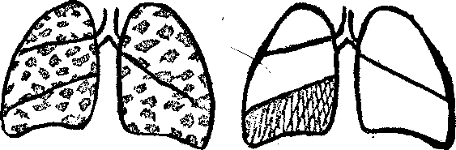
Bronchopneumonia Lobar pneumonia

Even in health the air-passages carry potentially dangerous bacteria and the lungs are continually exposed to infection by microorganisms in the air. Nothing happens unless resistance is lowered, as by illness. In such circumstances the lungs are very vulnerable. Infection primarily of the trachea and bronchi causes bronchitis, which can very easily become chronic, particularly where the continuous irritation of smoking exists. The characteristic symptom of chronic bronchitis is a regular cough with sputum.
Inflammation of the lungs from infection by viruses or bacteria is pneumonia. Pneumonia can be classified by the distribution of the affected alveoli, in lobar pneumonia the whole of one lobe or segment is involved. Bronchopneumonia affects groups of alveoli close to the larger air-passages, so that small patches of inflammation are scattered through the lungs. Since the discovery of antibiotic drugs for treating infection there has been less emphasis on the various patterns of pneumonia and more on the species of microbe, which determines the choice of drug.

9. Use this information in your discussion in the group

When children suffer from pneumonia they have the same symptoms as adults:

High temperature
Shortness of breath
Cough
Weakness
Headaches
Newly born and weak babies are often subject to pneumonia. Children having rickets, anaemia can easily catch it. Sick children must stay in bed. The room must be often aired. They must be often turned from side to side.
Mothers must keep such children in arms as often as they can. Small amounts of food must be given as often as possible. Fruits and vegetables must be included. It is necessary to drink warm water. Their skin must be always clean.
Pneumonia is treated with the help of antibiotics: penicillin and others. When the temperature falls mustard plasters must be applied.
To avoid pneumonia children must be washed with cold water from an early age

10. Continue the phrases using information from the texts

It is necessary......
It is wrong...........
It is important......

11. Choose the appropriate word from those given in brackets.
Translate the sentences into Russian:

1. (Dry, moist) rales were caused by diffuse bronchitis.
2. The shadow at the base of the left lung was particularly marked due to the
(enlargement, decrease) of the lymphatic glands.
3. (Mild, severe) forms of lobular pneumonia are difficult to differentiate from
pulmonary tuberculosis and pleurisy.
4. Luminal and bromide were prescribed to the patient (to improve, to impair) his
sleep.

12. Translate the sentences from Russian into English

- Высокая температура, кашель, слабость и одышка-это симптомы
воспаления лёгких .
- Многие антибиотики помогают лечить воспаление лёгких.
- Вчера мама поставила ребёнку горчичники, так как его температура
снизилась.
- Доктор порекомендовал давать ребёнку пищу малыми порциями.
- Подхватить воспаление лёгких могут дети с анемией и рахитом.

13. Study the text

Pneumothorax

In it air enters in pleural cavity from the lungs or from outside due to fracture of ribs or slab injury. Spontaneous pneumothorax occurs for no reason. It may cause chest pain or shortness of breath. Degree of breathlessness is proportional to the size of pneumothorax. If there is continual leakage of air the pneumothorax may be bigger and is likely to produce tension pneumothorax which may be life threatening. X-ray shows pneumothorax and may show underlying cause. A small pneumothorax heals within a few days.

14. Give a short summary of the text using the picture

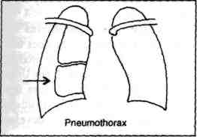

Using What You’ve Learned

Make up the dialogues. Role play the conversations

1. A- a teacher of therapy
B- a medical student
2. A- a doctor
B- a mother of an ill child.
3. A- a medical student
B- a medical student
4. Your own versions

Раздел V. Food as Treatment

Topic 12. Vitamins

1. What do you think about of vitamins in recovering after illness?
Share your opinion about it.

2. Study the words

deficiency-недостаточность, дефицит, отсутствие
kerato malacia-кератомаляция (расплавление роговицы)
prolonged-продлённый, пролонгированный
nausea-тошнота
megaloblastic-мегалобласт
glossitis-воспаление языка
hypospermia-гипоспермия
peripheral nervous system-периферическая нервная система
distal neuropathy-заболевание периферической нервной системы
enzyme-фермент
neurotransmitter-нейромедиатр
diarrhoea-диарея
cramps-судороги, спазмы
kidney stones-почечные камни
winter vitamins-зимние витамины
protect-защищать
eyesight-зрение
resistance-сопротивляемость
yeast-дрожжи
destroy-разрушать
increase-повышать
recover-выздоравливать
store-хранить, запасать
soya-соя

3. Fill in the gaps using new words

1. I can’t see anything, because my ...... is poor.
2. After illness he ..... very quickly and began working.
3. ....... of organism in winter is very weak, because of ....... deficiency of vitamins.
4. Yesterday at the lesson we studied ..... .... and teacher showed us a picture of an eye.
5. Many vitamins are....... during cooking.

4. Read the text and do the tasks after it

Vitamins

It is essential that the food of man and animals contains small amounts of the substances called vitamins. Vitamins are present in all kinds of food.
Vitamin is essential for normal functioning of the body. These are generally not manufactured by body. These are ACDEK and vitamin B complex group. These are required in small amount. These can be categorized into water soluble vitamins B and C and vitamin EDEK as fat soluble.
Vitamin A. It is required for bone growth, normal growth, normal vision and cell structure. Rich sources of vitamin A are liver, milk, green leafy vegetables. Yellow coloured fruits such as mango, papaya are rich source of it. Its deficiency is rare in well-to-do families but in poor children it may result in poor night vision, keratomalacia and even loss of vision. Skin may become rough and dry with loss of appetite.
Prolonged excessive use of vitamin A may result in headache, tiredness, nausea and loss of appetite.
Vitamin B₁₂ deficiency. It leads to two major syndromes, first is impaired DNA synthesis and is expressed most clearly in rapidly dividing cells. Deficiency results in megaloblastic anaemia, glossitis and hypospermia. Second is neurological syndrome and may affect peripheral nervous system resulting in distal neuropathy. B_{|2} deficiency may cause neuropsychiatric problem of an old age.
Vitamin-C It is an ascorbic acid needed for various enzymes and production of neurotransmitters. Principal sources are fresh fruits and vegetables. Daily requirement is 40 mg. Mild deficiency may cause weakness, pains, swollen gums and nosebleed. Excessive consumption for years may result in diarrhoea, cramps and kidney stones.
Vitamin-D The richest source of vitamin D is fortified milk and egg yolk. Body requires only small amount of it. Deficiency may develop in those who are deprived of sun light. Other causes may be liver and kidney disorder and some genetic defects. Prolonged use of phenytoin may also result in its deficiency. Long-term deficiency may lead to low levels of. calcium and phosphate which result in softening of bones. Condition is known as rickets. Excessive consumption may result in abnormal calcium deposits in soft tissue, kidney, blood vessels and may result in retarded growth.
Vitamin-E Chemically it is known is tocopherol. It is essential for normal cell structure to maintain certain enzymes and for the formation of blood cells. Principal sources are vegetable oils, nuts, meat, cereals specially wheat. Balanced diet provides all the needed quantity of vitamin E. It is known as antisterility vitamin also.
Vitamin-K It is essential for formation of substance in liver which promotes blood clotting. Principal sources are cabbage, broccoli, vegetable oils and egg yolks.
Prolonged treatment with antibiotics may result in its deficiency. Deficiency may lead to nosebleed, seeping of blood from wounds and gums.

5. Find in the text the English equivalents for the following words
and word combinations

1. содержит небольшое количество веществ
2. не вырабатываются организмом
3. подразделяются на
4. требуются для нормального роста
5. его отсутствие в благополучных семьях
6. фрукты, окрашенные в жёлтый цвет
7. продолжительное использование сверх нормы
8. отчётливо выражено в быстро делящихся клетках
9. нервно-психические проблемы в пожилом возрасте
10. проблемы с печенью и почками и некоторые генетические проблемы
11. необходимы для различных ферментов
12. что приводит к размягчению костей
13. известен как токоферол

6. Make up sentences using the following words

1. It, that, food, is, all, known, vitamins, of, present, in, kinds
2. improves, E, arteries, and, poor, Vitamin, circulation, hardens, blood
3. nervous, to, vitamins, build, system, strengthen, Winter, resistance, and,
infection
can, in, example, Vitamins, be, yeast, for, and, D, and, E, found, soya,
products, some, in.

7. Insert the missing words given below

- The synthetic vitamins are now recognized as being valuable therapeutic
agents for treatment of..... syndromes.
- Vitamins B1,2,6,12 and others are stated to belong to the ....... ....... vitamin
3. It is known to be essential for the ..... of normal epithelial tissue.
class.
4 ........ usage of many vitamins is ...... and even harmful.

( maintenance, water-soluble, deficiency, useless, prolonged )

8. Give information about definite vitamin and product which
contains it.

Use phrases

......contain(s) vitamin .... .
Vitamin.... helps to.... .

9. Translate into English the following sentences

1. Существуют водoрастворимые и жирорастворимые витамины.
2. Чрезмерное потребление витаминов может привести к нежелательным
последствиям.
3. Молоко и печень-богатый источник витамина А.
4. Дефицит витамина Д может привести к размягчению костей.
5. Витамин С, известный как аскорбиновая кислота, необходим для
производства нейромедиатра.
6. Долговременный недостаток витамина Д ведёт к рахиту.
7. В соответствие с растворимостью витамины делятся на две основные
группы:
1) растворимые в воде и 2) жирорастворимые.

10. Organize the Conference in your group and discuss the following questions

1. What must each diet contain?
2. Where can we get vitamins from?
3. What groups and categories of vitamins do you know?
4. What is Vitamin A for?
5. What are the symptoms of deficiency of Vitamin A?
6. What does the deficiency of Vitamin B12 result in?
7. What is the principal force of Vitamin C?
8. What leads to rickets?
9. What antisterility vitamin do you know?
10. What is the result of prolonged treatment with antibiotics?

Using What You’ve Learned

Fill in the table using information of the lesson

Vitamin | Product c Product containing it | Helps to ... | Deficiency | Overdosage

Topic 13. What Should а Man Eat?

1. Look at the picture. Share your opinion about what you eat most
often.

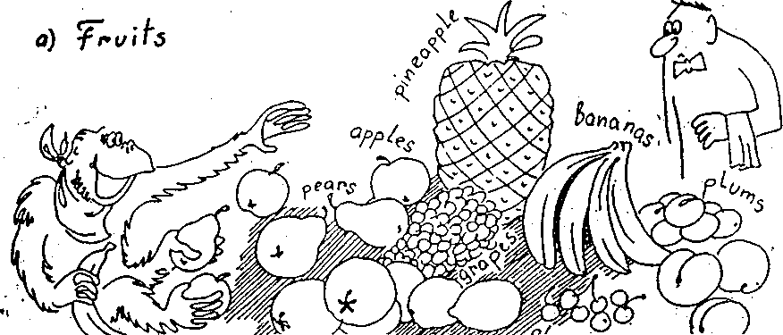
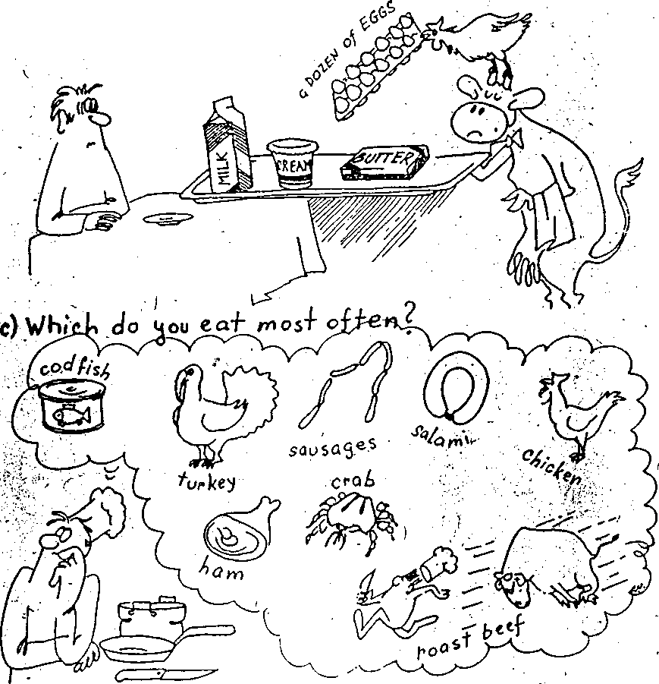

2. Give Russian equivalents to the proverbs and sayings

1. Too many cooks spoil the broth..
2. You cannot make an omelette without breaking eggs.
3. The proof of the pudding is in the eating.
4. Better an egg today than a hen tomorrow.
5. Hope is a good breakfast and a bad supper.
6. First comes, first served.
7. Hunger breaks stone walls.
8. It is no use crying over spilt milk.

3. Read the text about English food and eating habits and
discuss the following

1. How many meals a day do the English have?
2. What is the traditional English breakfast like ?
3. What do you have for breakfast?
4. What do the English usually have for lunch?
5. What is the favorite sweet ?
6. What is five o'clock tea?

The English usually have 4 meals a day: breakfast, lunch, tea ( five o'clock), and dinner. The traditional English breakfast is a meal of bacon and eggs, hot buttered toast or bread, jam, tea or coffee. English people sometimes have a plate of porridge or cornflakes for breakfast.
The second meal, lunch, is served at one o'clock. It consists of two courses or three courses. The first course is soup, then comes meat or fish. Beefsteak is the most popular meat dish. It is usually accompanied by potatoes or vegetables. Then comes a sweet. Apple pie is a favourite sweet.
The next meal is five o'clock tea. Tea is taken with milk. You may have some sandwiches or biscuits. Tea with lemon is called Russian tea. Guests are often invited to five o'clock tea.

4. Fill in the gaps using the words from the text

1 .My family always has three........ a day.
2.......................is served at one o'clock.
3. The English have......, eggs, hot buttered......and tea.
4. Some people have ...... ....for breakfast.
5. Would you have soup or........ for lunch?
6. Do you like an apple pie with.........?
7. Tea with lemon is called......... .
8. Last Friday at five o'clock I was invited to......
9. They take tea with... .

5. Study new words
To present- излагать
Harm- вред
Body weight- вес тела
Will burn up- перегорит
Substance- вещество
To replace- заменять
Raw- сырой
Intake- потребление
Per day- в день
Calorie- калория
Pure- чистый
Valuable- ценный
Brain- мозг
Sugar leads to sclerosis- сахар- причина
возникновения склероза
Trick- хитрость
Preserve- сохранить
Salted- соленый
Berry- ягода
Fats- жиры
Harmful- вредный
Treacherous- предательский
Conflicting opinions- противоречивые мнения
There is nothing to worry about- нет причин беспокоиться
The main conditions are observed- основные условия соблюдены
Protein- белок
Carbohydrate- углевод
Fat- жир, жирный
Mineral- минеральный, минерал

6. Read the text and answer the questions after the text

Diet plays a very important role in our life. It is impossible to work out mathematically what each person must eat. It is important to know that a diet must consist of enough of proteins, carbohydrates, fats, minerals, water and vitamins. All these you can find in meat, cheese, fish, liver, kidneys, eggs, milk, sugar and nuts.
A mixed diet of meat, fats, fruit, grain is best of all to those who want to be healthy. The aged must not eat so much as the young people.
Important factors of health of the digestive system are: exercise, well balanced diet, some glasses of water daily, regularity of meals and evacuation and freedom from hurry and worry.
If a reason is stout (fat) then a low caloric diet is given. The person takes less fat, carbohydrate and protein but plenty of green vegetables and fruit.

1. What must the diet contain?
2. What should a man eat to be healthy?
3. What is the diet in different ages?
4. Why should we eat mixed diet?
5. Who takes less fat? Carbohydrates and proteins?

7. Everybody has his own opinion about diet. Study the text and
share your opinion about thoughts of N. Amosov.

What Should a Man Eat?
A well- known Russian scientist and doctor Nikolai Amosov presents his ideas on what a man should eat.
First: It is important how much to eat rather than what to eat. The harm of any product is not great if the body weight is correct. The formula : weight=height minus 100 ( in kg and sm. ) . If this is combined with physical exercises it is still better: everything will burn up.
Secondly : The great role of vitamins, microelements and other biologically active substances. They can be taken only from fresh fruit and vegetables and cannot be replaced by anything else except raw meat and fish. How large should the intake of these components be ? The minimum quantity must be 300 grams per day or even 500 grams if not a kilogram. Different types of fruit and vegetables must be eaten. Replacement of raw vegetables by cooked ones is not the same. All culinary tricks to preserve the vitamins are useless. Man must get used to salted and fresh vegetables. Fruit and berries are also good but it is better to combine them with vegetables,
Third: Are fats harmful or not ? I think that they are treacherous rather than harmful since they have too many calories - nine per gram. The idea that fats should be eaten in their pure form is not true because man may get them from meat, milk and even bread. This is quite enough . Man should not look for some specially valuable fats if he wants to fight sclerosis.
Fourth: What about sugar ? And bread ? "Sugar is needed for the brain", "Sugar leads to sclerosis." One may often hear such conflicting opinions. There is nothing to worry about as long as the main conditions are observed : weight, intake of raw vegetables and fruit.

8. Work in pairs and answer the following questions:
l) What is the formula of ideal body weight?
2) Which is more important - what to eat or how much to eat ?
3) Why are physical exercises important ?
4) Where should the vitamins and microelements be taken from ?
5) What is the scientist's opinion on man's intake norm of fruit and
vegetables per day ?
6) Why does the scientist call fats treacherous ?
7) From what food products can man get fats ?
8) What can help man fight sclerosis ?
9. Find in the text the English for :
- известный учёный, по моему мнению, перегорит, формула: вес тела равен росту минус сто, сырое мясо, потребление овощей, соблюдать основные условия, самоконтроль, физические упражнения.

10. Study the following phrases . Remember the sentences in which they are used in the text , then use them in sentences of your own:
-to get experience ( knowledge , information , prize )
-a well-known ( famous , great) scientist
-a principal force ( energy , interest )
-replacement of raw ( fried , cooked , boiled ) vegetables
-are fats ( lard , butter, oil ) harmful ?
-conflicting opinions ( interests, feelings , emotions)
-to achieve one's purpose ( aim , results )

11. Replace the Russian words by suitable English equivalents in the correct form.
In Russia in 1965 the (ежегодное потребление) per capita of (картофеля) was 143 kg and (хлеба) 156 kg while now these figures are 122 and 140. At the same time the (потребление) of other products is growing and soon will (достигать) the scientific norms for the human diet. The intake of the higher quality of food like (мясо, молоко , яйца, овощи, фрукты, ягоды) is growing with every year. The intake of potatoes and bread is falling . Why do we (считаем , рассматриваем) these products more valuable than others ? It is because they are rich in (белок)т case of meat as well as in (минеральные соли) in case of (овощи , фрукты , ягоды). These products are (важны) for human organism.

Using What You’ve Learned
Using the following words make up the story what a man should eat
Doctor , recommendation , correct, formula , vitamin , microelement, biologically , active , substance , component, minimum , culinary , calories , sclerosis , control, conflict, fruit, diet, carbohydrates, fats, proteins.

Раздел IV. Texts for Reading
Text 1. Pediatrics.

Pediatrics is a science about a child's development and his diseases. Pediatrics originated from a Greek word: pais is a child, iatreia is treatment. In Russia the science began to develop at the beginning of the 19th century.
The first hospital for children was opened in St. Petersburg in 1834. Now it is named after the famouse Russian pediatrician Filatov.
The names of Khotovitski, Filatov, Gundobin, are well - known, not only in our country, but abroad. There is a Pediatric institution in St. Petersburg in which such famous doctors as Tur, Volovik, Speranski worked.
Russian scientists have contributed much to the problems of Pediatrics. They help children suffering from allergy, infectious and other diseases.

Text 2. Nursing of Children During Illness

It is very important for a sick child to have a good nursing. When we speak of nursing in illness we mean first of all cleanness of the child's room, bed and clothing.
When a child is ill he needs more fresh air. You must air the room no less than three times a day: in the morning, after the midday meal and at bed-time.
When you air the room cover the child warmly not to chill him.
It is good to have a small nursing table near the child's bed. You can keep different things on the table which you need in the care of the patient. A soft towel for his hands and face is placed on it.
The patient's hands are washed several times a day.
The nails are cut very short.
Dirty clothes are put immediately into a disinfectant. It is especially important in the case of dysentery or other infectious diseases.

Text 3. Heart Disease Risks

Certain risk factors can increase anybody’s chances of developing heart disease. These risks include life style and family history. Some risks are:

Age. The older you get the more likely you are to develop heart disease.
Sex. More men develop heart disease and develop it earlier than women do. The gap begins to narrow after the menopause and women "catch up" with men around 65.
Heredity. If members of your family have had heart disease, you are more likely to develop it. Race is also a risk factor: Black Americans have a greater risk of heart disease than white Americans mainly because they have higher average blood pressure levels.

Text 4. Accessory Aids of Blood Circulation

It was obvious even to primitive man that the pulsating heart was a pump distributing to the brain and all other parts of the body important substances, including nourishment from the gastrointestinal tract and liver. However, it was not until the middle ages and later that the details of circulation were discovered.' In later years it was found that certain accessory aids help the heart in maintaining an optimal circulation of the body. Undoubtedly the most important aid is that of the large muscles of the leg, which on contracting, squeeze the veins in the legs and thus relieve the heart of about one third of its work when the legs are used actively, as in cycling, running, swimming or jogging. A second important aid is that of the elasticity of the

aorta. When hardening of the aorta wall develops as a result of arteriosclerosis, the advantage of natural elasticity is lost. A third aid is a freely moving diaphragm. When the diaphragm moves up and down, the chest cavity becomes a suction pump that help to bring blood up from below as well as to bring air into the lungs. A fourth aid is the arterial system's ability to adjust to the changing demands of different organs. During the process of active digestion the blood supply to the gastrointestinal tract has greater priority than that to the skeletal muscles, which are at rest. During exercise, the situation is normally reversed, with skeletal muscles receiving priority over the gastrointestinal tract.

Text 5. Heart Failure
As the heart has only one function, to pump all the blood it receives from
the veins into the arteries, so in a sense it has only one disease, failure to do
so. But heart failure has many causes.
As fast as blood arrives from the veins a healthy heart pumps it into the arteries. The heart is in "failure" when it does not pump the blood quite as fast as it arrives. As a result the veins become congested with blood and the pressure in them rises. The circulation then goes on as before, but with a constant accumulated blood. The heart no longer empties itself with each beat.
The heart failure is divided into two groups; those due to poor output (forward failure) and those due to congestion on the veins (backward failure). Forward failure affects the whole body: all tissues need an adequate supply of fresh blood, and when the supply is reduced nothing in the body functions quite as well as it should be.
The symptoms of congestion are due not so much to overfilling of the veins as to leakage of water into tissues, causing edema (dropsy). At least three mechanisms operate in heart failure. The roost obvious is the raised pressure in the capillaries which prevent them from absorbing water from the tissues. Secondly, poor circulation deprives the capillaries of their full quota of oxygen and causes them to leak. Thirdly, poor circulation in the kidneys causes too much salt to be retained in the body. The relation to other disease is very complex, for on the oik; hand heart failure lowers the efficiency of other organs and on the other hand chronic disease, especially the lungs and kidneys can lead to heart failure.

Text 6. Heart Block

Heart block improper formation of sinoatrial impulse and its propagation through the junctional tissues of heart is known as heart block. It may be SA block, A V block, bundle branch block or arborisation or Purkinje block. It leads to dizziness, stroke or fainting attacks. It may be caused by coronary heart disease, myocarditis, overdose of digitalis drug.
The rate of ventricle beat is slower than normal and in complete heart block the rate

does not increase after exercise. Pulse becomes lesser than 50 per minute.

Mild block does not require treatment.
In severe case pace maker is fitted.

Text 7. Heart Burn

It is the burning pain in epigastrium and may be caused by overeating, spicy prickles, and alcohol consumption. This pain is generally mistaken for heart attack. Antacid and anticholinergic drugs are helpful.
Heart transplant is a complex form of surgery undertaken to replace a patient's diseased heart either with a healthy one from donor or a mechanical one. Close matching has to be done.

Text 8. Heat Exhaustion

It is caused by overexposure to heat, when person it not accustomed to work in hot environment. Insufficient water intake and diminished consumption of salt precipitate it. Symptoms include faintness, fatigue, headache, restlessness and heat cramps. Skin it pale and clammy. Breathing is shallow and fast. Pulse is rapid and weak. Glucose saline intravenous drip and antipyretics help the patient. Patient should be shifted to cooler place and whole body sponging will relieve the fever.

Text 9. Chromosomes.

These are the thread-like structures present in nuclei of cells. Chromosome carries the inherited, and genetic information, growth and functioning of entire body. Each and every cell of body contains similar type of chromosomes because each is derived from one cell only after repeated divisions.
Chromosomes determine the shape of eyes, nose, colour of hair, skin and pupils. Each chromosome contains up to several thousand genes arranged in single line.
Chemically a chromosome consists of extremely long chain of hereditary substance DNA along with a coating of protein. Total unit is known as chromatin. The sequence of chemical units in DNA provides the coded instructions for cellular activities. Out of 23 pairs of chromosomes 22 are the same in both sexes known as autosomal chromosomes. One member of each is derived from mother and another from father. The other two chromosomes are called sex chromosomes. In women they are known as 'X' chromosome while in men one is 'X' chromosome and another very small “Y” chromosome. “Y” chromosome is responsible for male characteristics. In its absence female pattern is developed.

Text 10. Chronic Fatigue Syndrome

The tension exerted by contraction of a muscle may fatigue due to disordered neuromuscular transmission. On exercise, intracellular acidisis may occur out of proportion to the associated rise in high energy phosphate changes in muscle metabolism have been reported in studies of NMR spectroscopy in patients with postviral fatigue syndrome. Malaise and fatigue are common in those given interferons in trials of treatment of multiple sclerosis.

Text 11. Chronic Gastritis

It is a chronic form of dyspepsia. There will be pain or distress in epigastrium especially after fried food. Pain may be in back or may shot up to shoulder. It may be relieved by eructation. Appetite is diminished. There is a bad taste in mouth. The tongue is dry, flabby and indented by teeth. There are languor, headache, depression, disturbed sleep, fatigue, discomfort and drowsiness after meals. In first stage of congestion hydrochloric acid is diminished. Second stage is mucous catarrh in which there is large secretion of mucus and hydrochloric acid is completely absent. In third stage there is atrophy of mucous membrane. Macrocytic anaemia may be associated, affected and its failure later causes right ventricle to fall.

Text 12. Chronic Leukaemia

Course may extend up to many years. There is insidious beginning with enlargement of spleen, lymph nodes and weakness. Chronic myelocytic leukaemia is characterised by great increase in leucocytes in blood. Many immature cells, myelocytes and myeloblasts are present and total blood count may reach to 500,000 per cubic millimetre. Platelet count increases. Chronic lymphocytic leukaemia is having lower white cell count usually less than 100,000 cubic millimetre of which 90 per cent or more are lymphocytes.
Oral symptoms are always present and consist of gingival hyperplasia. These are constant in monocytic form. In majority of cases gingival infiltrates are found. Under microscope lesions show dense infiltration of connective tissue by immature cells of lymphoid and monocytic series.

Text 13. Operation a Hundred Years Ago

...Obviously Dr. Mayo did not operate in a well ordered world of men in white. His was "kitchen surgery". The theatre was usually the patient's home, the operating-table one from the kitchen or the parlor sofa, or even a door taken off its hinges and laid across two saw-horses. The room was seldom large enough and Dr. Mayo often refused to permit the presence of anyone but those who were helping him.
Modern men accustomed to strict asepsis in operative routine and surroundings can scarcely credit the stories of pre-antiseptic methods, stories of men who operated in whatever shirt or coat they happened to be wearing, covering it perhaps with a linen duster or an apron stiff with the stains of previous operations; who stropped their knives on the soles of their shoes before they began and while using one knife held another ready between their teeth; who economized on water that had to be carried in from the well by squeezing the blood from the sponge instead of washing it out; who washed their hands after and not before the operation.
Word of the work of Pasteur and Lister was getting around by 1880 but more as the story of scientific truth. Microbes still belonged to the realm of fantasy, and the concept of cleanliness was still beyond the comprehension of most men.
As for cleanliness of instruments, sponges, towels-well, wasn't it rather silly when the operation itself was so messy. Little is known especially of Dr. Mayo's methods. Being fastidious in dress and person he may have kept his few instruments fairly clean, free at least of dried blood between operations, but they were certainly not sterile. Some of them he carried in a little case or even loose in his vest pocket where he could reach them easily to lance a boil or clip the ragged edges of a minor wound.
He may have removed his long black coat for the task to allow himself greater freedom of movement or to save the garment from soiling. But perhaps he shared that peculiar sense of value which made it a matter of pride for the surgeons to perform an amputation without spotting the whiteness of shirt cuff or front. It is said that Henry J. Bigelow of Boston, one of the nation's ablest surgeons at that time always operated in a well-valuated dark blue coat with a rose in the buttonhole.

Text 14. The Road to Painless Surgery
Pain-killing drugs such as opium, hemp and mandrake were used by the Chinese surgeon Hua To in the second century A. D. and by others even earlier. The drugs were actually only slightly successful in easing pain.
Drastic methods were used by some early surgeons. Assyrian doctors strangled children into unconsciousness before performing circumcision. Others knocked the patient out by striking a wooden bowl on his head.
Ether was first used as an anesthetic in 1842 by an American physician Crawford W. Long, who removed a tumor from the neck of a friend. Four years later W. T. Morton, an American dentist, demonstrated in public the use of ether during the operation. Painless surgery was now a fact. Laughing gas, the popular name for nitrous oxide, exhilarated those who sniffed it. But the gas had important merits, as the American dentist Horace Wells proved in 1844 when he had a tooth extracted painlessly while under the gas. The use of chloroform to ease the pains in childbirth was pioneered in 1847 by Sir James Y. Simpson, a Scottish doctor. Queen Victoria was one of the first women to take chloroform for this purpose. Modern methods of anesthesia have banished pain from the operating room and have contributed to the development of surgery. New and better anesthetic such as: halothane and cyclopropane have been developed.

Text 15. Surgery

In the operating room patients are operated on. A sore organ or a part of it is removed. During the operation anesthesia is applied. All the doctors and nurses wear special gowns while working in the operating room.
The operating room must be very clean. It is washed before the operation and after it. During the operation the instruments which have been used are taken away.
The nurse must prepare herself for the operation beforehand. All the instruments must be sterilized. The nurse must be the first to be ready for the operation.
She washes her hands in a special solution, puts on a sterilized gown and a mask and prepares a table for the instruments. Then she helps the surgeon to get ready for the operation.
During the operation she gives the doctor all the necessary instruments. The nurse must know very well how the operation will be carried out.
After the operation the nurse bandages the patients.
The nurse is responsible for the state of the operating room.

Text 16. Operating room Technique
The words "Operating room" have a formidable sound to most people. To the average layman, it is the one place in the world to which he hopes he never will have to go. The surgeon knowing that so much depends upon his skill is working under strain and tension. The nurse is the person who must think quickly and logically, be scrupulous and conscientious. Team work, cooperation and conscientiousness are essential in any ward situation but never more so than in the operating room, where a minute's delay, a weakened ligature, a glove, unnecessary questioning of orders may mean the life of the patient.
When assisting the surgeon in performing operations the nurse must carry out aseptic technique. All instruments, gauze and other materials which come in compact with the wound are sterile. The patient is draped with a sterile towel and the doctor wears sterile gloves. A sterile field is set upon a tray, on which instruments and dressing are placed. Everything should be done to prevent organisms from entering the wound and thereby causing infection.
The entire operating room should be spotlessly clean.
The furniture and equipment should be arranged to permit the greatest amount of efficiency. The room should be well ventilated but with no draught to the patient. All materials needed for the operation should be selected and brought to the operating room in advance. Instruments should be selected and tested to see that they work properly and easily. A chemical solution is made and knives, needles, scissors and other articles which need to be sterilized in this manner are placed in it and left for twenty minutes.

Раздел V. Applications
1. Tables

Showing weight for height in males

Height | Weight | Overweight | Underweight
cm | kg | limit (+2%) | limit (-20%)
148 | 47.5 | 57.0 | 38.0
152 | 49.0 | 59.0 | 39.0
156 | 51.5 | 62.0 | 41.0
160 | 53.5 | 64.0 | 43.0
164 | 56.0 | 67.0 | 45.0
172 | 62.0 | 74.6 | 49.5
176 | 65.6 | 78.5 | 52.4
180 | 68.5 | 82.0 | 55.5
184 | 72.0 | 86.5 | 57.5

Showing weight for height in females

Height | Weight | Overweight | Underweight
cm | kg | limit (+20%) | limit (-20%)
148 | 46.5 | 56.0 | 37.0
152 | 48.5 | 58.0 | 39.0
156 | 50.0 | 60.5 | 40.5
160 | 52.5 | 63.0 | 42.0
164 | 55.0 | 66.0 | 44.0
168 | 58.0 | 69.5 | 46.5
172 | 60.5 | 72.5 | 48.5
176 | 64.0 | 77.0 | 51.0
180 | 67.0 | 80.5 | 53.5

Nutritive value, citrus fruits

(Per lOOg)
Nutrients | Grapefruit | Lemon | Lemon  (sweet) | Lime sweet (Malta) | Lime sweet (Musambi) | Orange | Orange juice
Calories (K cal) | 32 | 57 | 35 | 36 | 43 | 48 | 9
Protein (gm) | 0.7 | 1.0 | 0.7 | 0.7 | 0.8 | 0.7 | 0.2
Fat(gm) | 0.1 | 0.9 | 0.3 | 0.2 | 0.3 | 0.1 | 0.1
Carbohydrates (gm) | 7.0 | 11.1 | 7.3 | 7.8 | 9.3 | 10.9 | 1.9
Calcium (mg) | 20 | 70 | 30 | 30 | 40 | 26 | 5
Iron (ng) | 0.2 | 2.3 | 0.7 | 1.0 | 0.7 | 0.3 | 0.7
Carotene dig) | — | 0 | 0 | 0 | 0 | 1104 | 15
Vitamin C(mg) | 31 (Juice) | 39 (Juice) | 45 | 54 | 50 | 30 | 64

Total fiber content of common foods (g\100 g)
High |  | Medium | Low | Nil
(<10) |  | (1 to 10) | (<1)
Wheat |  | Rice | Refined | Sugar
Jowar |  | Most vegetable | processed | Fats/oils
Bajra |  | Most fruits | foods | Milk
Ragi |  | Coconut |  | All types of meat
Maize |  | Sesame (til) |  | meat
Legumes
Dais (Pulses)
Fenugreek

Approximate nutrient value of common cooked foods

 |  |  | No. of | Weight of | Energy |  |  | Fat |  | Protein
 | Item |  | serving | cooked preparationnnn
 |  |  |  | (g) | (Kcal) |  |  | (g) |  | (g)
I. | Cereal preparations
 | Rice |  | IK | 100 | 110 |  |  | 0.1 |  | 2
 | Idli |  | 1 | 60 | 75 |  |  | 0.1 |  | 2
 | Plain dosa |  | 1 | 40 | 125 |  |  | 3 |  | 3
 | Masala dosa |  | 1 | 100 | 200 |  |  | 6 |  | 4
 | Phulka |  | 1 | 35 | 80 |  |  | 0 |  | 3
 | Paratha |  | 1 | 50 | 150 |  |  | 4 |  | 4
 | Upma |  | IK | 130 | 200 |  |  | 9 |  | 5
 | Sevian upma |  | IK | 80 | 130 |  |  | 4 |  | 3
 | Bread toasted |  | 2 slices | 50 | 170 |  |  | 1 |  | 4
 | Poha (Awal) |  | IK | 100 | 200 |  |  | 9 |  | 2
 | Dalia |  | IK | 140 | 165 |  |  | 7 |  | 5
 | Khichri |  | IK | 100 | 210 |  |  | 7 |  | 4
 | Puri |  | 1 | 25 | 80 |  |  | 3 |  | 2
II. |  | Pulse preparations
 |  | Plain dal | IK | 140 |  | 170 | 4 |  |  | 10
 |  | Sambar | IK | 160 |  | 81 | 2 |  |  | 4
 |  | Chhole/Sundal | 1 K | 150 |  | 115 | 5 |  |  | 7
III. |  | Vegetable preparations
 |  | With gravy | IK | 130 |  | 130 | 7 |  |  | 3
 | Dry |  | IK | 100 |  | 115 | 7 |  |  | 2
 | bajara baigan |  | IK | 170 |  | 230 | 20 |  |  | 3
 | Vegetable kofta |  | 1 K | 145 |  | 220 | 14 |  |  | 4
IVvvVV. | Fried snacks
 | Bhaji |  | 1 | 7 |  | 35 | 3 |  |  | 0.5
 | Samosa |  | 1 | 65 |  | 210 | 12 |  |  | 2
 | Kachori |  | 1 | 45 |  | 200 | 12 |  |  | 3
 | Potato vada |  | 1 | 40 |  | 100 | 5 |  |  | 3
 | Sago vada |  | 1 | 30 |  | 100 | 6 |  |  | 1
 | Fried snacks
 | Masala vada |  | 1 | 20 |  | 56 | 2 |  |  | 2
 | Vada |  | 1 | 20 |  | 65 | 3 |  |  | 3
 | Dahi vada |  | 1 | 80 |  | 170 | 9 |  |  | 5
 | Vegetable cutlet |  | 1 | 30 |  | 70 | 5 |  |  | 1
V. | Chutneys  Coconut/groundnuts/
 | coriander |  | 1 tbsp | 25 |  | 64 | 5 |  |  | 3
 | Tomato |  | 1 tbsp | 50 |  | 10 | 0.3 |  |  | 0.3
VI. | Non-vegetarian preparations
 | Boiled egg |  | 1 | 50 |  | 86 | 7.0 |  |  | 7.0
 | Omlette |  | 1 | 65 |  | 155 | 14.0 |  |  | 7.0
 | Fried egg |  | 1 | 50 |  | 155 | 14.0 |  |  | 7.0
 | Mutton curry |  | IK | 145 |  | 240 | 18 |  |  | 10
 | Chicken curry |  | IK | 125 |  | 260 | 15 |  |  | 26
 | Fish (fried) |  | 2 pieces | 85 |  | 220 |  |  | 12 | 18

VII. Bakery products  Biscuits | 2 | 40 | 220 | 14 | 3
Cake | 1 | 40 | 220 | 13 | 3
Vegetable VIII. Sweets | 1 | 60 | 170 | 10 | 3
Laddu, burfi, etc. Halwa (Suji) Doubleka meetha | 1  I K 1 K | 60 130 105 | 250 430 280 | 15 20 18 | 8 3 4
Custard/puddings Chilcki | 1 K  2 | 110 60 | 180 300 | 6  12 | 5 8
Jam/Jelly | 1 tsp | 7 | 20 | 0.04 | 0.04
K = Katori = Approximate 125 g

Showing balanced diet for different sex and age groups

Food Item |  | Adult Man |  | Adult Woman |  |  | Children |  | Boys 10-12 | Girls 10-12
 | Sedentary | Moderate | Heavy | Seden-tary | Moderate | Heavy | 1-3 | 4-6
 | work | work | work | work | work | work | yrs | yrs | yrs | yrs
Cereals | 460 | 520 | 670 | 410 | 440 | 575 | 175 | 270 | 420 | 380
Pulses | 40 | 50 | 60 | 40 | 45 | 50 | 35 | 35 | 45 | 45
Leafy | 40 | 40 | 40 | 100 | 100 | 50 | 40 | 50 | 50 | 50
vegetables
Other | 60 | 70 | 80 | 40 | 40 | 100 | 20 | 50 | 50 | 50
vegetables
Roots | 50 | 60 | 80 | 50 | 50 | 60 | 10 | 30 | 30 | 30
and tubers
Milk | 150 | 200 | 250 | 100 | 150 | 200 | 300 | 250 | 250 | 250
Oil and fat | 40 | 45 | 65 | 20 | 25 | 40 | 15 | 25 | 40 | 35
Sugar or | 30 | 55 | 55 | 20 | 20 | 40 | 30 | 40 | 45 | 45
jaggery

Salads, fruits and calories

Item | No. | Weight | Kcal
 | (Medium size) | (g)
Beetroot | 1 | 65 | 30 1
Cabbage | 1 | 250 | 70
Carrot | 1 | 40 | 20
Cucumber | 1 | 90 | 12
Lettuce | 6 bundles | 100 | 20
Onion | 1 | 50 | 25
Radish | 1 | 60 | 10
Tomato | 1 | 50 | 10
Turnip | 1 | 100 | 30
Item | No./ |  | Kcal
 | Quantity
Apple | 1 |  | 65
Banana | 1 | 80 | 90
Grapes | 30 | 100 | 70
Guava | 1 | 100 | 50
Jackfruit | 4 pieces | 100 | 90
Mango | 1 | 250 | 180
Musambi/orange | 1 | 100 | 40
Papaya | 1 piece | 250 | 80
Pineapple | 1 piece | 100 | 50
Sapota | 1 | 80 | 80
Custard apple | 1 | 130 | 130
Watermelon/muskmelon | 1 piece | 100 | 15

Fatty acid composition and cholesterol content of animal food

Item | Fat  g/100_{g} | Saturated  fatty acids g/lOOg | Choles-  terol mg/lOOg
Butter | 80 | 50 | 250
Ghee | 100 | 65 | 300
Milk (cow) | 4 | 2 | 14
Milk (buffalo) | 8 | 4 | 16
Milk (skimmed) | 0.1 | - | 2
Milk (condensed) | 10 | 6 | 40
Cream | 13 | 8 | 40
Cheese | 25 | 15 | 100
Egg (whole) | 11 | 4 | 400
Egg yolk | 30 | 9 | 1120
Chicken without skin | 4 | 1 | 60
Chicken with skin | 18 | 6 | 100
Beef | 16 | 8 | 70
Mutton | 13 | 7 | 65
Pork | 35 | 13 | 90
Organ meats
Brain | 6 | 2 | 2000
Heart | 5 | 2 | 150
Kidney | 2 | 1 | 370
Liver | 9 | 3 | 300
Fresh water and
Sea foods
Prawns/shrimps | 2 | 0.3 | 150
Fish (lean) | 1.5 | 0.4 | 45
Fish (fatty) | 6 | 2.5 | 45
* Values vary depending on the feed of the animals
• One whole egg or yolk of one egg contains 210 mg cholesterol

Food guide for a healthy heart

Foods | Prefer | Limit | Avoid
Cereals ragi, bajra,  Pulses  Vegetables | Wheat, rice with maida maize, jowar Whole and sprouted Green leafy vegetables and other vegetables | White bread, biscuits  Roots and tubers | Cakes. pastries, naan rati, noodles  Fried vegetables, banana chips, canned vegetables
Fruits  Dairy products | Fresh fruits  Low fat milk, Buttermilk skimmed milk | Whole milk. Milk powders | Dried fruits, canned fruits in syrup. Cheese, butter knoa, condensed milk, mlik cream
Eggs  Animal  foods | Egg white Fish | Chicken | Egg yolk prawns, shrimps, all types of meat
Fat | More than one type of vegetable oil | Total fat intake | Oily dishes, butter, ghee, coconut oil, fried foods
Sugar | Sugar, jaggery | Sugar in any  home-made  beverages | Sweets like  chocolates  icecreams
Nuts and  oilseeds  Beverages | Fresh fruit juice light tea | All nuts and oilseeds coffee, cola, soft drinks | Alcohol
Salt | Foods in  natural  state | Too much salt in preparations | Pickles, papads, sauces, salt biscuits, fried crispies
2. Diet and Diseases
Diabetes Mellitus

The following food articles should be avoided
- sweet drinks and carbonated drinks
- dried and canned fruits
- cakes, pastries, cream, and alcohol drinks
- sugar, potatoes
Diabetes primarily concerns the utilization of carbohydrates in the diet. Insulin which is manufactured in the pancreas is required mainly to convert glucose circulating in the blood into glycogen in which form it is stored in the muscles of the body. If insulin is insufficient glucose will build up in the blood and urine. A diabetic should know how to adjust his or her diet in order to keep his or her urine free of sugar.
Carbohydrate
Less than 250 g should be consumed. But drastic reduction of carbohydrate is forbidden as it might result in excessive metabolism of fat resulting in ketoacidosis.
Calories
Total calories should be adequate for the growing children and underweight persons. For the obese patients it, is necessary to reduce calories. They should consume more of green leafy vegetables which are filling in capacity, low in calorific value and contain less than 3% carbohydrate.
Proteins
1 g/kg of body weight, cheese is a good source of protein. Low consumption of fats will keep the cholesterol level low. High doses of B complex vitamin will avoid the development of diabetic neuritis.
Of the minerals potassium helps in release of insulin from pancreas.
Sweetening Agents
There are two chief sweetening agents. One is saccharine in liquid, tablet or granule form.
Saccharine is a coal tar derivative 300 to 500 times sweeter than glucose and does not have any calorific value; of the sugars fructose is the sweetest (173) then sucrose (100), glucose (74) and lactose (60). Sugar free can be used by those obese diabetics who have a craving for sweets. One tablet provides only 0.4 calorie which is sufficient to sweeten one cup of tea.
Sorbitol is hydrogenated glucose and is converted into fructose in the body and hence does not cause glycosuria. Tonics of diabetics contain sorbitol.

Diet Sheet

Bed tea | Coffee/tea 1 cup
Breakfast | Tea 1 cup
 | 2 toasts with little butter
Lunch | Fulka—2 (two)
 | Rice—1 medium bowl, Dal—3\4th
 | medium bowl.
 | Leafy vegetables—1 bowl.
 | oil for cooking—1V4 Tsf
Afternoon | Light tea without sugar
Evening | Fruit/I
Dinner | Fulka—2 small, Rice—1 medium bowl
 | or 2 more vegetables—1 medium bowl
Bedtime | Glass toned milk without sugar
Approximate calories | 1500
Carbohydrate below | 230 g

Infective Hepatitis

Proteins
Excessive intake of protein is harmful because of protein break down products may accumulate leading to coma. With mild hepatitis 60 to 80 g of proteins are permitted.
Fats
May be limited up to 30 g daily
Carbohydrates
Large quantities of oral carbohydrates are given because
They constitute the major source of calories.
They minimize the endogenous proteins breakdown. If vomiting/nausea persists intravenous glucose should be given.
For mild jaundice 2000 calories and in severe jaundice 1600 to 2000 calories are recommended.
Vitamin B complex and vitamin C are helpful. Sufficient quantities of sodium chloride and potassium chloride to have electrolyte balance may be consumed.

Diet Sheet

Early morning • Light tea—1 cup with 10 g sugar
Breakfast • Fruit juice—150 ml + 15 g sugar
Jam—2 tablespoon.
10 am • Sugar cane juice—1 glass
Lunch Rice—2 medium bowl, Thin Dal Vi
medium bowl, butter milk 1 cup+sugar.
4 pm • Light tea + 2 Tsf sugar.
Banana 1 medium size.
Dinner Fulka—2 medium size, mixed fruits 250 g
well-cooked vegetable 1 bowl.

Cholecystitis

Food to be avoided are
- Pastries, cheese, fried potato chips.
- Fatty meat, fried eggs
- Cabbage, cauliflower, cucumber, peas and beans
- Nuts, popcorn and dry fruits.
- Pickles, condiments and spices.
Proteins
One gm/kg body weight is permitted, very high protein intake may increase
biliary cholesterol.
Fats
Restricted fat diet.
Calories
Minimum carbohydrates to maintain the calories. High carbohydrates will
increase the biliary cholesterol.

Diet Sheet
Early morning • Light tea—1 cup with sugar
Breakfast • Toned milk without sugar, Toast 2 with
little jam
Lunch • Rice—1 medium bowl, Fulka—4 small thin,
Thin dal—3\4th medium bowl,
Thin butter milk
• Egg—one, cooked french beans and carrots,
oil or cooking—I1\2 spoon.
4 PM . Light Tea—1 cup with 1 Tsf sugar.
Biscuits 3 to 4
Dinner • Fulka—4 small cooked mixed
vegetable—1 bowl, Dal—3\4th bowl, Orange-1
Bed time • Milk—1 cup without sugar and cream

Ischaemic Heart Disease

Proteins
1 g/kg of body weight in normal weight patient.
Fats
Saturated fats are to be avoided such as:
Animal fats—beef, meat, pork
Fats procured from dairy products such as cream, butter, ghee.
Hydrogenated vegetable oils.
Unsaturated fats such as kardi oil, sunflower oil, etc. can be used.
Carbohydrates
These are responsible for endogenous synthesis of cholesterol and triglycerides.
Reduction in sugar intake decreases serum triglycerides.
Calories
Reduction of calories will reduce the weight.
Vitamin C is required for capillary stability. Nicotinic acid reduces lipids in blood, hence both are useful.
Adequate potassium and calcium in blood are required to prevent arrhythmias. Salt restriction is necessary in hypertension of heart failure.
Smoking is hazadous as it produces myocardial oxygen deficiency, increases beta and prebeta lipoproteins and enhances atherosclerosis.

Diet sheet

Bed tea *Light tea without sugar
Breakfast *Milk one cup without sugar or cream
Lunch *Fulka 4 small size without ghee
*Rice one medium bowl, salad
*Cooked vegetables 3|4th bowls
oil for cooking-1 1|2 tsf
4P.M. *Light tea without sugar or milk
*Sweat lime and papaya
*Fulka-2medium size
*Pulses 3|4th medium bowl
*Salad
*Curd-3|4 the medium bowl
Dinner *Oil for cooking 1 1|2 tsf
*Cooked vegetables 3|4th medium bowl

Underweight

Following should be encouraged
• Sweetened fruit juices
Milk and its products. Cheese, butter and sweets
Bread, jam and jelly
Dried nuts and fruits
Meat and eggs
Proteins
1.2 to l.S g/kg or more
Fats
These are encouraged to increase weight. These should not be taken in the beginning of food otherwise they will decrease the appetite. Large quantities may produce diarrhoea, flatulence and gastrointestinal upsets.
Carbohydrates
Potatoes, sweet potatoes, biscuits and sweets should be consumed in good quantity. Banana is a good source of calories.
Calories
Total calories consumed should be more than the required to put on weight. Green leafy vegetables should not be consumed in sufficient quantities because these are not good source of calories but may fill up the stomach. Fluids should not be taken before and during meals. Sufficient vitamins are to be consumed.

Diet Sheet
Bed tea Light tea 1 cup with sugar 2 Tsf.
Breakfast Milk one cup with sugar 1 Tsf, Bread 2 slices
butter 10 gm. Cheese 25 or one egg.
Lunch Fulka 4 small with ghee.
Rice one medium bowl,
Dal one medium bowl,
Curd 3/4th bowl + 1 Tsf sugar
Diet will provide 1800 calories, 40 of proteins.

Evening Preparation of 50 g, groundnut,
fruit juice 1 glass, Banana 1
Dinner Fulka 2 small with ghee. Fried rice 2 bowl.
Curd 1/2 bowl. Dal fry 3/4th Bowl,
Mixed vegetable 1 bowl,
Ice cream/sweet 50 gm.
Bedtime Milk one glass.
Constipation

Proteins
Normal 1 g/kg body weight.
Fats
Ghee and oils are beneficial and act as lubricant to the bowel and stimulate the bile flow for appropirate digestion.
Carbohydrates
Fruits like banana, figs, cucumber with skin and ladies finger are preferred. Cellulose stimulates peristalsis by forming a bulk and facilitate evacuation. Yeast which is rich in B complex helps to regulate the bowels. Liberal fluid intake and warm milk intake at bedtime are helpful.

Diarrhoea

Food to be avoided are:
Deep fry, spicy articles
Sweets, dry fruits
Chutney, pickles
Salad and cellulose containing food.

Proteins
Protein rich substance like skimmed milk, white of an egg, butter milk are helpful. If diarrhoea is due to milk allergy, milk is to be avoided.
Fats
Fats will not be absorbed when there is intestinal hurry. They may aggravate the diarrhoea and are best avoided.
Carbohydrates
Easily digested carbohydrates, soft vegetables not with much of cellulose can be given.
As chronic diarrhoea may result in malnourishment high calories may be provided. Diarrhoea may result in loss of fluids and electrolytes. They must be replenished orally or in emergency Intravenously.
Salted biscuits, fruit juices and oral electrolyte solutions will be helpful.

3. General Measures

Measures of weight (mass) in metric system

1 Kilogram (kg) = 1000 gram (g or g)
I gram = 1000 milligram (mg)
1 milligram (10-3 g) = 1000 microgram (meg)
I microgram (10-6 g) = 1000 nanogram (ng)
1 nanogram (10-9 g) = 1000 picogram (pg)
1 picogram (10-12 g) = 1000 femlograms (fg)

Measures of capacity (volume) in metric system
1 litre (I) = 1000 millilitres (ml)

Measures of weight (mass) in imperial system
1 pound (lb) = 1 ounce (oz) = 7000 prain

1 ounce = 437.5 grains (gr)

Measures of capacity (volume) in imperial system

1 quart = 2 pints (pt or 0)
1 pint = 20 fluid-ounces (fl oz)
I pound = 16 fluid-ounces
I fluid ounce = 8 fluid drachms (fl dr)
! fluid drachm = 60 minims (min)

Domestic weights and measures

Domestic measure Imperial Metric
equivalent
= 1 minim | = 1/20 ml
= 1 fl dr | = 4 ml
= 8 ml
= 4fldr | = 15 ml
= 2floz | = 60 ml
= 6floz | 180 ml
1 drop
1 teaspoonful
1 dessert
1 table spoonful
1 wine glassful
1 teacupful

1 tumbleful = 240 ml

Relation between Metric and Imperial system

1 kilogram = 2.2046 pounds
1 gram = 15.432 grains (15 gr approx)
1 pound = 453.59 grams
1 ounce = 28.35 grams (30 G approx)
1 grain = 65 milligrams (60 mg approx)
1 litre = 1 quart (approx)
1 litre = 1.7598 pint
1 millilitre = 15 to 20 minims
I fluid ounce = 30 ml (approx)

4. Latin Words Used
ad ad | up to
ante cibum | ac | before meals
aqua | aq | water
aqua destillate | aq dest | distilled water
bis in die | bid | twice daily
compositus | co or comp | compound
concentratus | cone | concentrated
cum | c | with
dilutus | Dil or dil | diluted
divide | div | divide
et | et | and
fiat | Ft or ft or f ft | let it be made
guttae | Gutt or gtt | a drop
hora somni | hs | at bed time
inter cibum | ic | between meals
misce | m | mix (thou)
mistura | mist | a mixture
mitte tales | mittal | send (thou) such
nocte | noct or n | at night
omni hora | oh | every hour
post cibum | pc | after meals
post prandium | p prand | after dinner
pro re nate | prn | as need arises
pulvis | pulv | a powder
quarter in die | pid | four times a day
quantum suficient | qs | as much as may be required
quaque hora | qh | every hour
quaque quarta hora | qq hor. | every four hours
signa | sig | label
sine | s | without
statim | st | immediately
si opus | sit sos | when required
spiritus | spt | spirit
syrupus | syr | syrup
ter in die | tid | thrice daily
ter die sumendus | tds | to be taken three times a day
tinctura | tine or tr | a tincture
unguentum | ung | an ointment

5.a) English-English Medical Terminology

An artery - any of the muscular walled tubes which help to
form the blood circulation system of the body.

Cardiovascular - everything which relates to the heart and blood vessels.

Diagnosis - the identification of a disease by means of a patient’s
symptoms.

A diet - a special course of food to which a person is restricted,
esp. for medical reason or to control weight.

A laboratory - a special room or a building for scientific experiments
and research work or for the manufacture of drugs and
chemicals.

Medicaid - a Federal system of health insurance in the US for
those requiring financial assistance, or in the
other words – “Medical+Aid”.

Medicare - a Federal system of health insurance in the US for
persons over 65 years.

A medicament - a substance used for medical treatment.

Medicate - treat medically.

A medicinal plant - a plant having healing properties

Medicine - 1. the science or practice of the diagnosis, treatment
and prevention of the disease.
2. any drug or preparation used for the treatment or
prevention of the disease.

A prescription - a doctor’s written instruction for internal or external use
of a medicine.

A ward - a special room in a hospital for in-patients or people
who are hospitalized.

An ambulance - a special car for transportation of ill or injured people to
or from the hospital.

A doctor - a qualified practitioner of medicine, a physician with
higher education.

A nurse - a doctor’s assistant, who had special training at the
medical college in caring the sick people.

A hospital - an institution providing medical and surgical treatment
and nursing care for sick people.

A surgeon - a person who makes different operations in the operating
room.

An operating - a special room where different operations are made by a
room surgeon.

A patient - a person who needs medical help.

A stretcher - a special thing for carrying sick or injured people and are
used by hospital attendants.

A chemist’s - a specialized shop where you buy different kinds of
shop medicines for headaches, heartaches, cough, colds, quinsy
and others.

5. b) Russian-English Medical Terminology

Врач - a doctor, a physician, a practitioner.

Здравоохранение - Public Health, Health Protection, Health Service.

Заболеть - to be ill, to be sick, to fall ill.

Болезнь - illness, sickness, disease, case.

Измерить пульс – to take blood pressure, to check blood pressure, to
measure blood pressure.

Больница - a hospital, a clinic.

Лечить - to treat, to cure, to heal.

Лечение - treatment, cure, healing.

Защищать - to protect, to defend.

Вены - veins, blood vessels.

Лекарство - medicine, drug, remedy.

Выздоравливать - To recover, to be well again.

Терапевт - a therapeutist, a therapist, a physician.

Боль - pain, ache.

Простудиться - to catch a cold, to catch a chill, to have a cold.

У меня насморк - I have a running nose, I have a cold in my head.

Грипп - grippe, flu, influenza.

Терапия - therapy, medicine.

Таблетки - pills, tablets.

Литература

- Алёхина А.И. Краткий русско-английский и англо-русский фразеологический словарь. - Мн .: Издательство БГУ, 1980-400с.

- Городкова Ю.И. Латинский язык для учащихся медицинских и фармацевтических училищ – Ростов н\Д: Феникс, 2001.

- Маслова А.М.., Вайнштейн З.И. Учебник английского языка для медицинских вузов. – 2 изд. испр. и испр. – М.: Высшая шк., 1983 – 352 с.

- Мухина В.В., Мухина Н.С., Скрипников П.Н.-Английский язык для медицинских училищ: Учебное пособие – Мм: Высшю шк., 2003.

- Oxford Explanatory Dictionary (new edition, printed in London).

- Oxford Intermediate Learner’s dictionary (new edition, printed in London) – London, Oxford University Press.

- Patricia R. Werner, Mary Mitchel Church, Lida R Baker. A
communicative grammar. The McGraw-Hill Companies, Inc. 1996г.

- Pocket Medical Dictionary with 500 illustrations. Golden
Books Centre SDN. BHD., [ T – 142884 ]

- Тылкина С. А., Темчина Н. А. Пособие по английскому языку для медицинских училищ. – 3-е изд., перераб.- М.:
Высш. шк., 1985. 160с.

10. Францева Л.Ф.Самоучитель английского языка для медиков. Москва
2002.

